Kuberenetes

Class-1

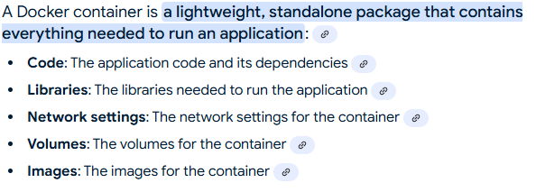

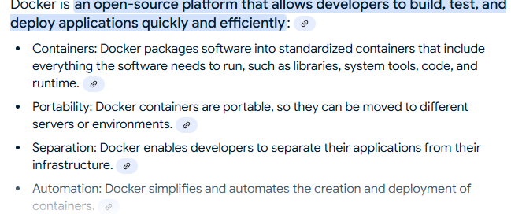

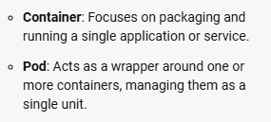

# Kubernetes basic

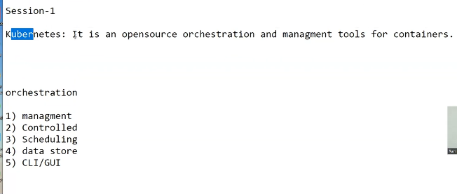

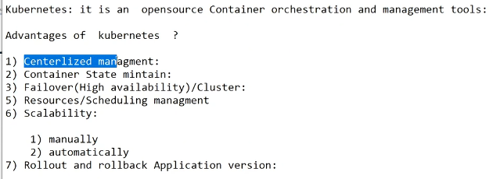

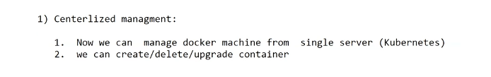

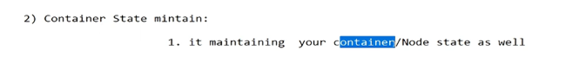

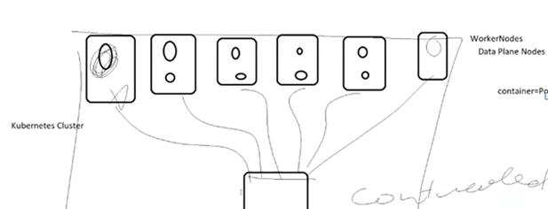

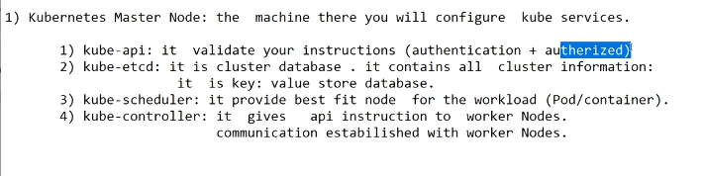

IAAS : 10 number of EC2 machine : 10 number : 1 master node and 9 worker node : kubeadm

Laptop: hypver-V : 3 machine : K8s

Public cloud : create 3 Ec2 machine : ready the manual k8s cluster

Public cloud : AWS : EKS :

PAAS : AKS, GKE, EKS : ready platform :

SAAS

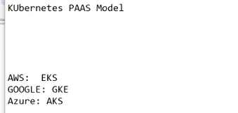

Container-d for docker and kubernetes

Cri-o for redhat openshift

Google has devolved the kubernetes and open source.

AWS : Ec2 machine :

redhat and openshift platform :

Openstack : nova :

Openshift

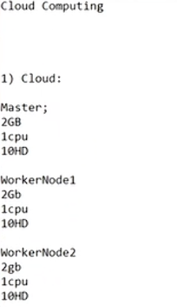

Install kubeadm in AWS EC2 machine ;

[Getting started | Kubernetes](https://kubernetes.io/docs/setup/)

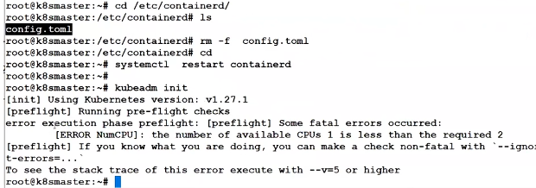

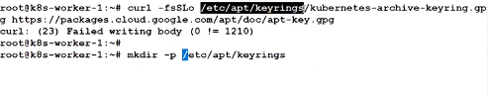

Kubeadm init

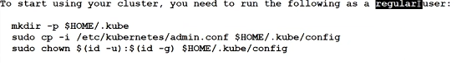

Kubelet : agent

Kubectl : command

Kubeadm : installation utilty to ready the cluster

AWS :

1 year access :

EC2 ; 1 cpu 1 GB : free tier

Cluser :

AWS : EKS :

Laptop : hypervisor : 3 Cenots machine :

We can use private subnet : cluster.

Worker node :

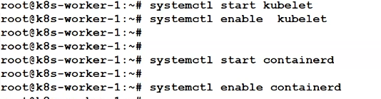

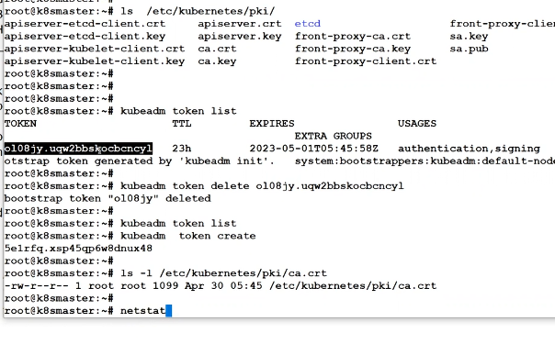



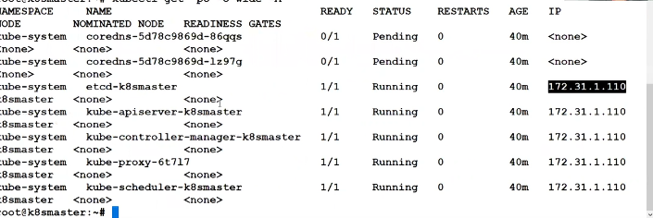





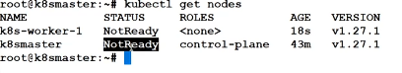

Calico need to install

Command:

Master Ubuntu

apt-get update

apt-get install -y apt-transport-https ca-certificates curl

curl -fsSLo /usr/share/keyrings/kubernetes-archive-keyring.gpg https://packages.cloud.google.com/apt/doc/apt-key.gpg

echo "deb [signed-by=/usr/share/keyrings/kubernetes-archive-keyring.gpg] https://apt.kubernetes.io/ kubernetes-xenial main" | sudo tee /etc/apt/sources.list.d/kubernetes.list

apt install containerd

apt-get install -y kubelet kubeadm kubectl

kubeadm init

kubeadm init --ignore-preflight-errors=all

cp -i /etc/kubernetes/admin.conf $HOME/.kube/config

mkdir .kube

cp /etc/kubernetes/admin.conf .kube/config

kubectl get pod -A

history

d

kubectl create -f calico.yaml

kubectl get nodes

kubeadm token create --print-join-command

kubectl get nodes

history

Worker Node

apt-get update

apt-get install -y apt-transport-https ca-certificates curl

curl -fsSLo /usr/share/keyrings/kubernetes-archive-keyring.gpg https://packages.cloud.google.com/apt/doc/apt-key.gpg

echo "deb [signed-by=/usr/share/keyrings/kubernetes-archive-keyring.gpg] https://apt.kubernetes.io/ kubernetes-xenial main" | sudo tee /etc/apt/sources.list.d/kubernetes.list

clear

apt install containerd

o apt-get install -y kubelet kubeadm kubectl

apt-mark hold kubelet kubeadm kubectl

kubeadm join 172.31.32.151:6443 --token twvupt.c9h12ojc6lywt7km --discovery-token-ca-cert-hash sha256:c63ff01bbf7fcf968d31e85d51a91a9e89724d7766504cc8b45a8ba383ca68b0

kubeadm join 172.31.32.151:6443 --token twvupt.c9h12ojc6lywt7km --discovery-token-ca-cert-hash sha256:c63ff01bbf7fcf968d31e85d51a91a9e89724d7766504cc8b45a8ba383ca68b0 --ignore-preflight-errors=all

Installation on local laptop :

Centos :

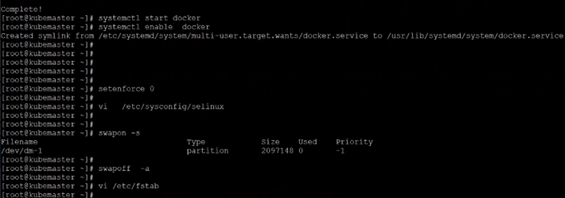

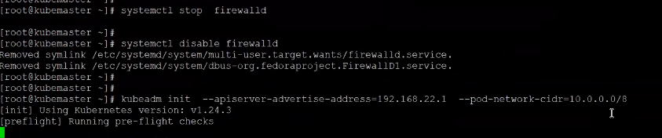

1 hostnamectl set-hostname worker-2

2 exit

3 clear

4 sudo apt-get update

5 sudo apt-get install -y apt-transport-https ca-certificates curl gpg

6 curl -fsSL https://pkgs.k8s.io/core:/stable:/v1.30/deb/Release.key | sudo gpg --dearmor -o /etc/apt/keyrings/kubernetes-apt-keyring.gpg

7 echo 'deb [signed-by=/etc/apt/keyrings/kubernetes-apt-keyring.gpg] https://pkgs.k8s.io/core:/stable:/v1.30/deb/ /' | sudo tee /etc/apt/sources.list.d/kubernetes.list

8 sudo apt-get update

9 sudo apt-get install -y kubelet kubeadm kubectl

10 sudo apt-mark hold kubelet kubeadm kubectl

11 sudo systemctl enable --now kubelet

12 history

Centos on laptop :

Hyper-v

Master and worker-1/worker-2 VM on centos 8

How to add the ip in centos 8 :

nmcli connection add con-name abcd ifname eth1 type ethernet autoconnect yes ip4 192.168.17.2/24

nmcli connection up abcd

Master :

sudo yum install -y yum-utils

sudo yum-config-manager --add-repo <https://download.docker.com/linux/centos/docker-ce.repo>

sudo yum install docker-ce docker-ce-cli containerd.io docker-buildx-plugin docker-compose-plugin

sudo systemctl start docker

sudo docker run hello-world

/etc/sysconfig/selinux

Disabled

swapoff –s

Swapon –a

/etc/fstab delete the swap line

*# This overwrites any existing configuration in /etc/yum.repos.d/kubernetes.repo*

cat <<EOF | sudo tee /etc/yum.repos.d/kubernetes.repo

[kubernetes]

name=Kubernetes

baseurl=https://pkgs.k8s.io/core:/stable:/v1.30/rpm/

enabled=1

gpgcheck=1

gpgkey=https://pkgs.k8s.io/core:/stable:/v1.30/rpm/repodata/repomd.xml.key

exclude=kubelet kubeadm kubectl cri-tools kubernetes-cni

EOF

sudo yum install -y kubelet kubeadm kubectl --disableexcludes=kubernetes

sudo systemctl enable --now kubelet

systemctl start kubelet

rm -rf /etc/containerd/config.toml

systemctl restart containerd

systemctl stop firewalld

systemctl disable firewalld

kubeadm init --apiserver-advertise-address=192.168.17.1 --pod-network-cidr=10.0.0.0/8 --ignore-preflight-errors=all

mkdir -p $HOME/.kube

sudo cp -i /etc/kubernetes/admin.conf $HOME/.kube/config

sudo chown $(id -u):$(id -g) $HOME/.kube/config

kubectl get nodes

worker :

firewall stop

fstab swap off

docker ce install

kubeadm install

remove config.toml

systemctl start kubelet docker

systemctl enable kubelet docker

rm -rf /etc/containerd/config.toml

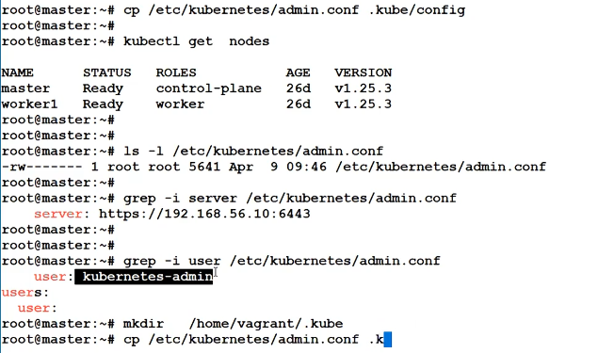

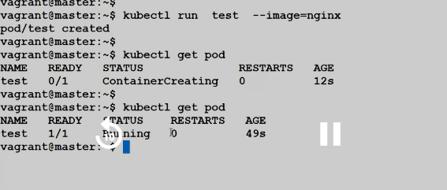

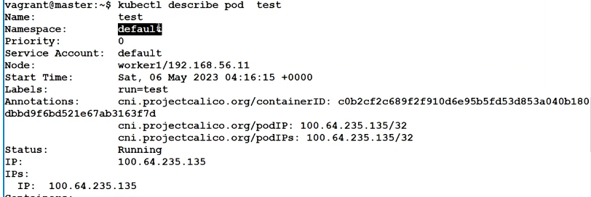

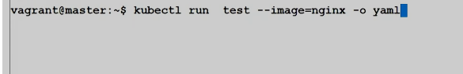

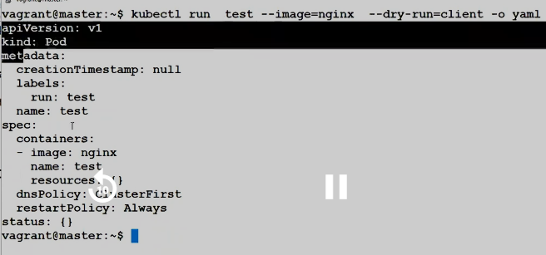

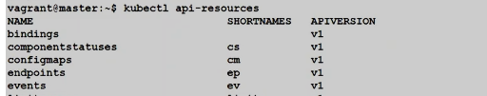

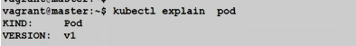



HYPER-V:

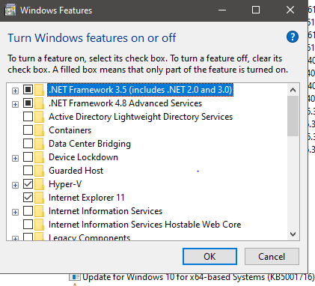

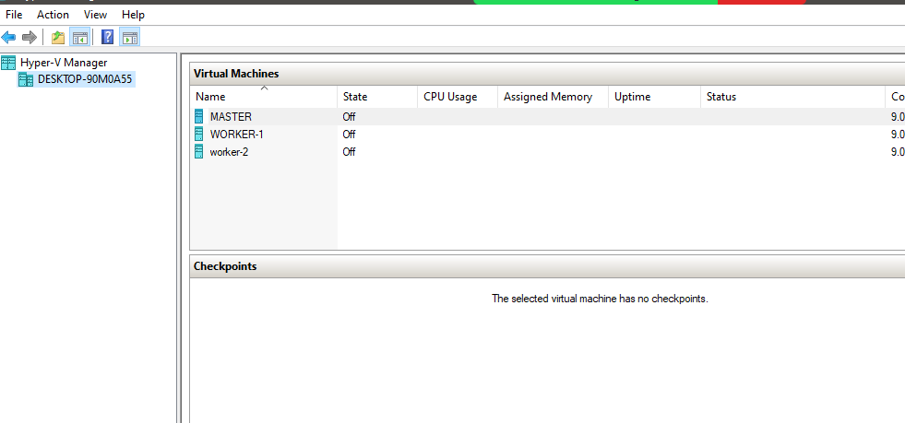

Class :2

Kubectl command :

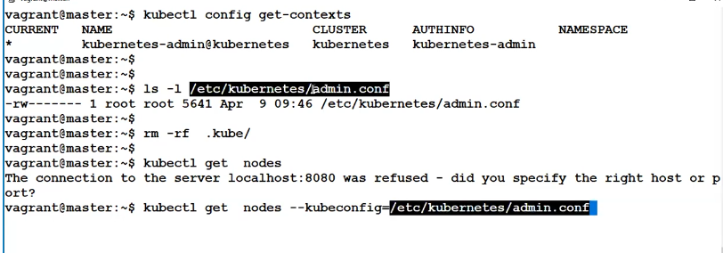

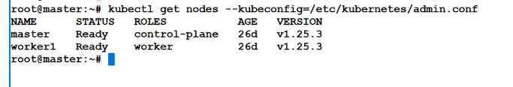

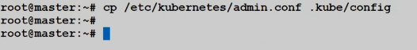

Orphan pod :

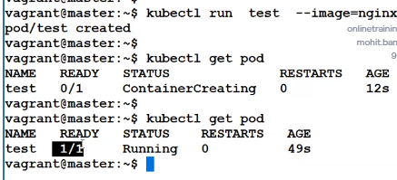

Manifest understanding of YAML :

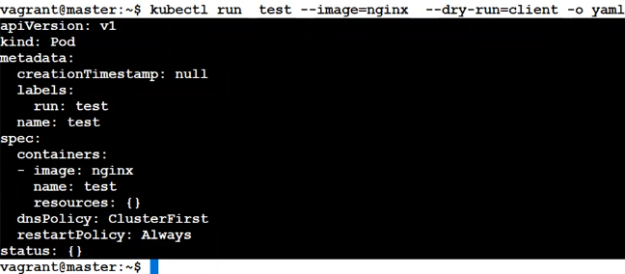

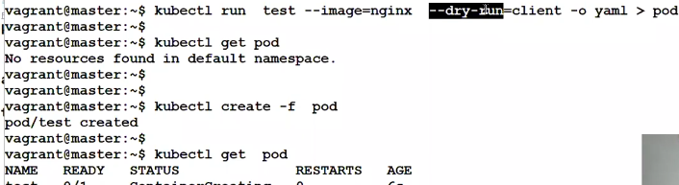

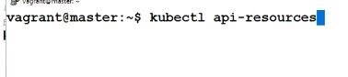

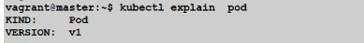

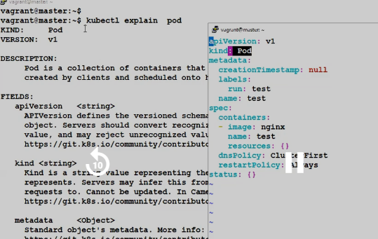

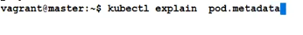

YAML   
 string

List

Mapping

Mandatory parameter in yaml if create the pod :

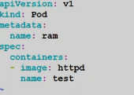

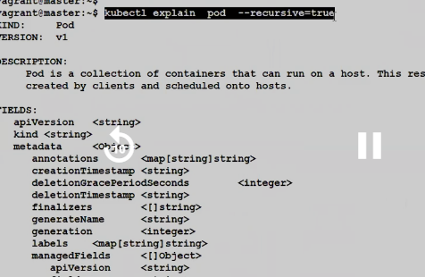’

Pod scope :

Cluster wide--------------------false

Namespace wide --------------true

Volume cluster wide but pod namespace wide

Class 3 :

Replication controller:

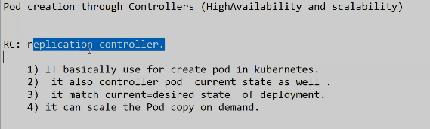

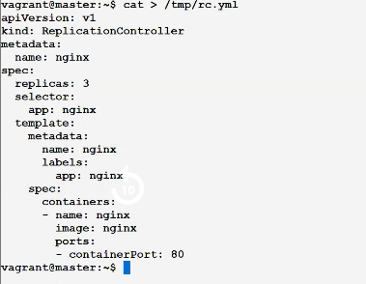

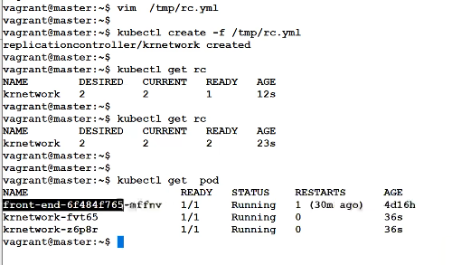

Delete the pod and new pod auto come :

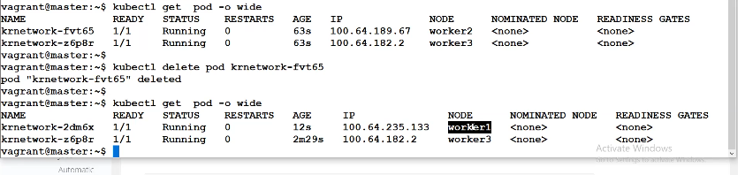

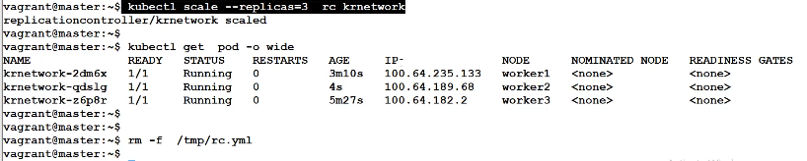

Orphan and RC details :

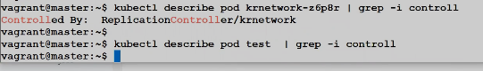

If u want to change the replica

Change the value in yaml and apply the yaml

Change the value in command –replicas count 2 to 3

Can take the backup of yaml from the runining rc and delete rc and create again.

Change the value in direct etcd cluster file of replica count of particular RC – kubectl edit rc <rc-name>

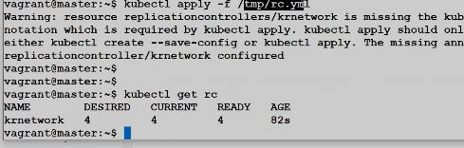



Labels:

We created 3 pod with blue, blue , red

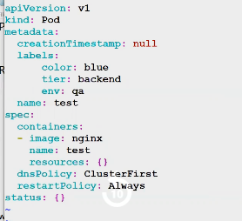

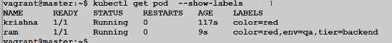

Label can give from command:



Label can replace mean override:

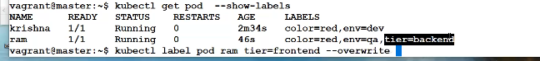

Label in RC :

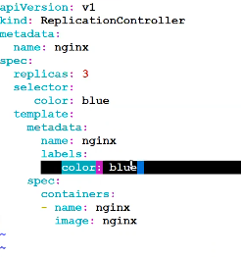

Now will explain the selector

For example I create the orphan pod test with label of color=blue and RC also have same label color=blue with replica count 3

Expected value 3+1 = 4 but we got 3 pod because they consider orphan pod color blue as part of RC

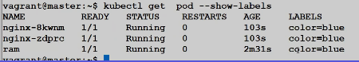

Selector will check the blue color and it will be RC

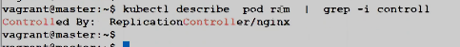

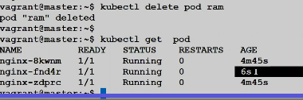

Label and selector value should be match.

If not give the selector in yaml then label will become selector

Kubectl describe rc <rc-name>

Deployment key point

If not label then label will be selector

RC and RS diff is set based selector only in RS not in RC

DC having rolling strategy 25 % max and 30 sec grace period default

Recreate the rolling strategy in DC

In RC/RS don’t have rolling update strategy and can upgrade but need to delete and recreate the pod.

Scheduling :

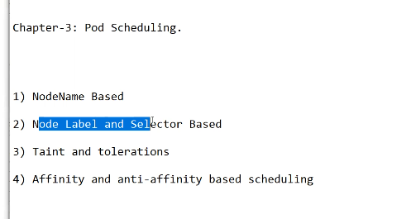

In scheduling deployment can give the node name first but no failover because always pod will go to worker02

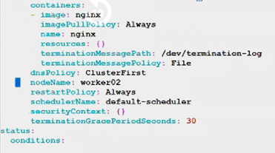

Node label and selector:

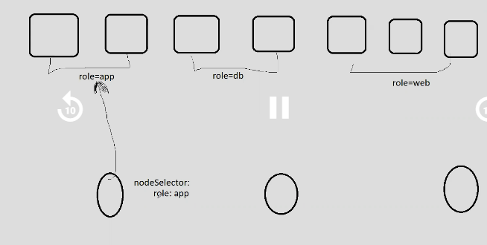

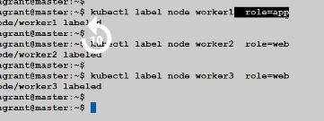

On deployment:

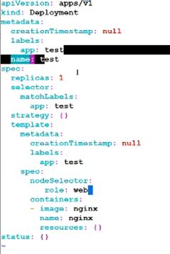

If give wrong label and selector in case pod will be pending and check the pod describe state.

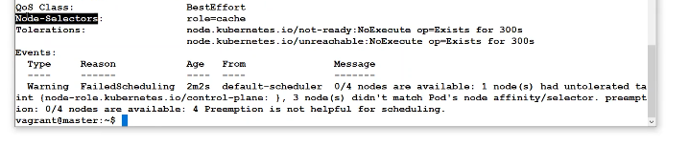

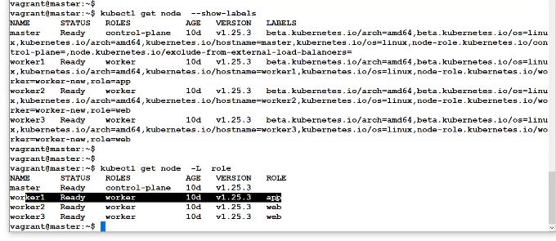

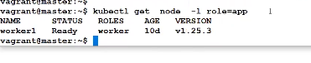

Can change the label of worker node:

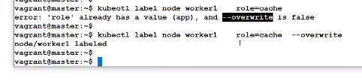

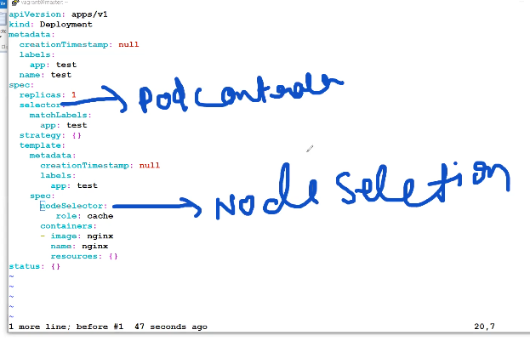

We normally check node selector to select the node by pod in deployment but we not use this in production and we have one more advance namespace label for node selection.

Namespace level :

Annotiation added

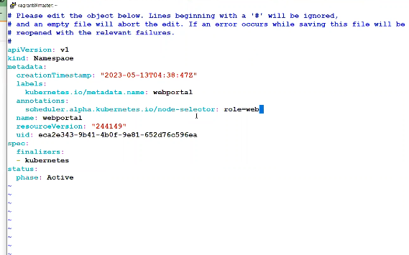

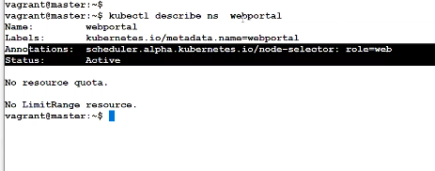





Add the node selector in API for namespace

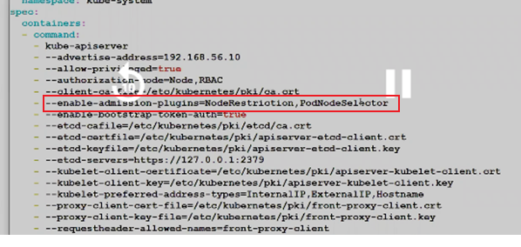

Check the enable :

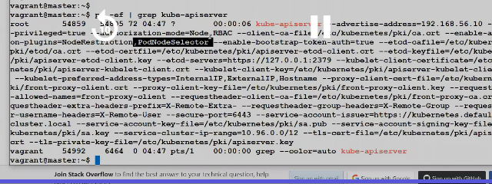

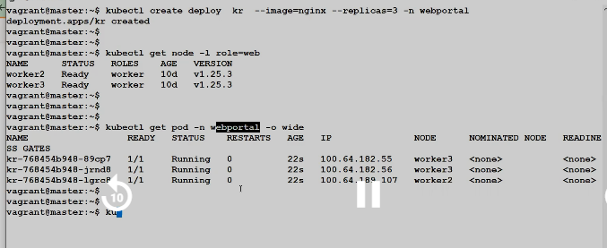

If deployment in worker1 as node name but in namespace node selector worker2/3

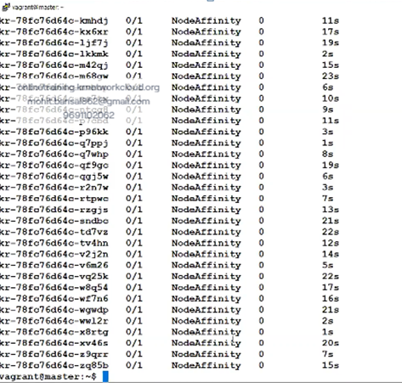

Pod will fail IF CHANGE THE NAMESPACE AND NODENAME VALUE

taint and toleration:

In taint and toleration having dedicated NEC

U create first role=web with worker-1/2.

If u create the test deployment in that case all pod of test deployment will go to worker-2/3 but rest other normal pod also can go to worker2/3

If u want dedicated the worker2/3 for your pods in that case need the taint and toleration.

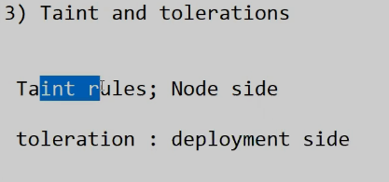

When u do the node taint in that case must need to give the label

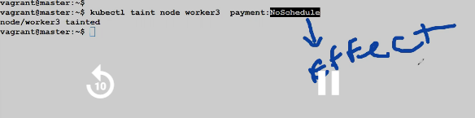

If u want to go on worker-3 in that case deployment need to give the same toleration value.

Now no worker-3 not getting

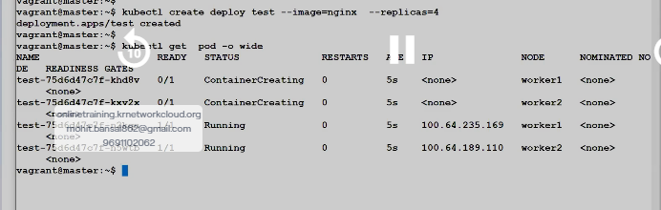

But u can do but edit to deployment.

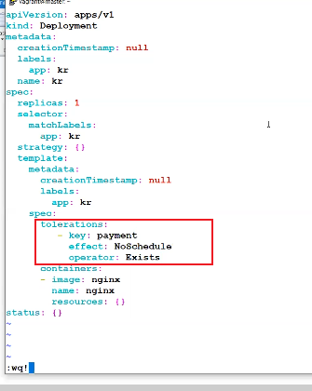

Now new deployment KR on worker-3

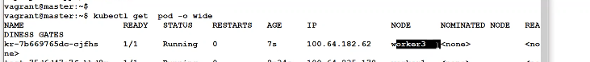

Can we use both node selector and taint & toleration same time ?

yes

we scale KR from replica 1 to 3 but KR deployment having toleration value.

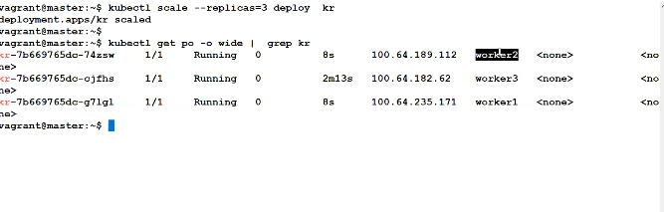

If u want to keep all pod In master node in that case first master need to do the un-taint with toleration value and need to give level to master node like role=master then need to give nodeSelector role=master in deployment file.

Untained the node command :



Master node untained the node:

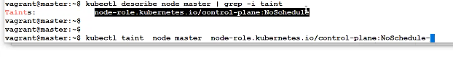

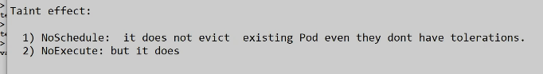

No schedule mean the already deployed pod won’t impact with this effect.

No Execute mean the existing pod will be deleted if doesn’t have the toleration value.



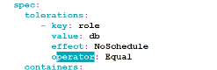

Operator two type

Exists == only key or value should match

Equal = both key and value should match

Afiinity and anti affinity rules:

Affinity : same node

Anti afiinity : diff node

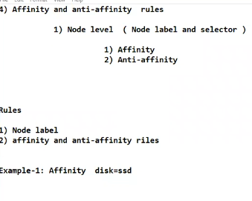

With affinity and anti affinity can have multiple condition but node level selctor are static.

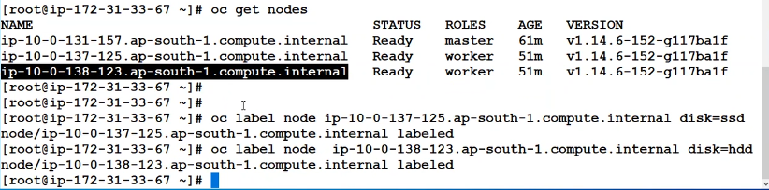

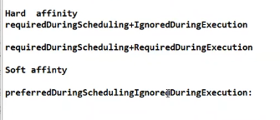

If deployment done and node level changed after some time in that case first case apply then ignore the level

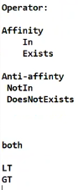

Node 1 : level disk=ssd

Node2 : level disk=hdd

First pod will deploy on Node-1 if node-1 not available in that case pod will be node-2

If level wil remove post deployment in that case pod will not re-schedule and delete and re-create case will be problem only.

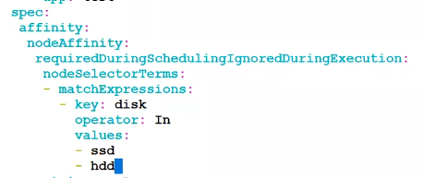

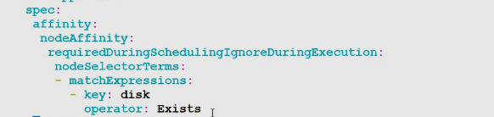

Same command but NotIn and DoesNotExists

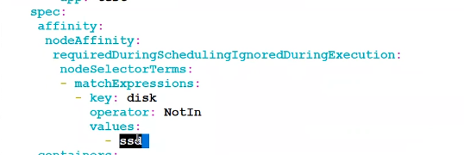

IN Operator need to pass the value like disk=ssd here key is disk and value will be ssd

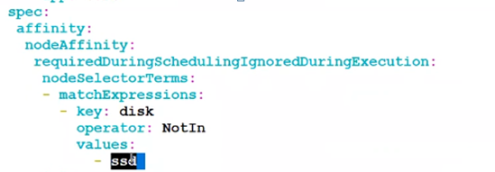

exists Operator no need to pass the value like disk=ssd here key is disk and value will be ssd

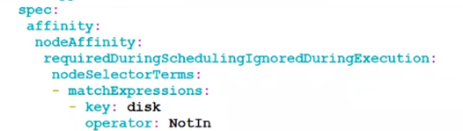

Affinity and anti affinity rule also for pod level

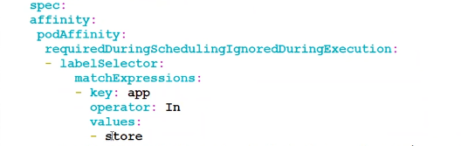

Networking

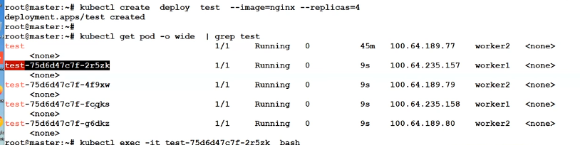

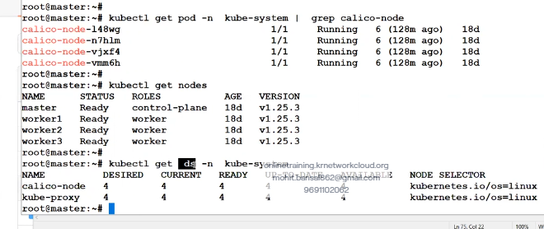

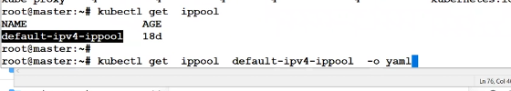

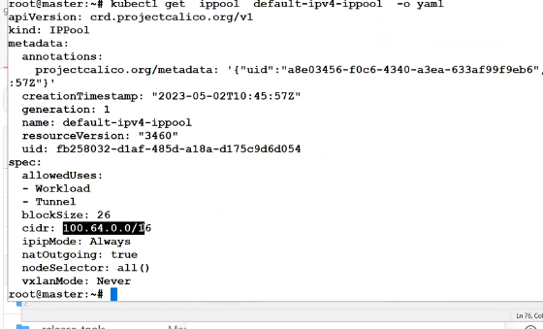

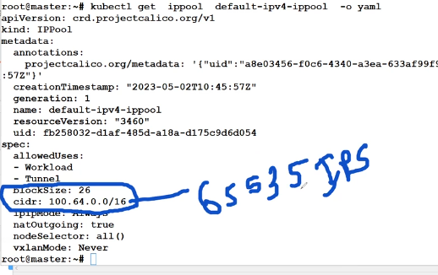

Custome network pool

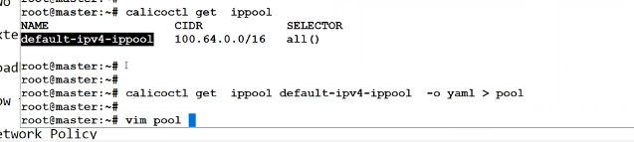

Custom.yaml

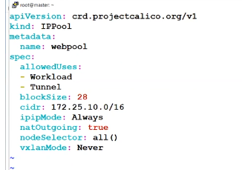

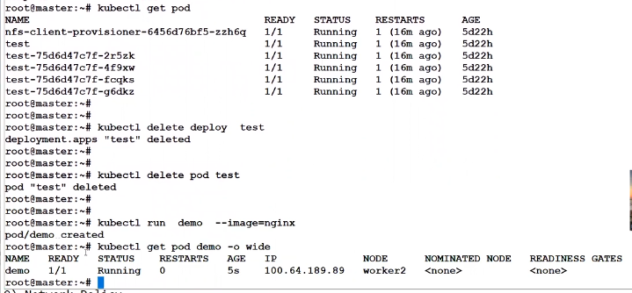

By default demo pod won’t get the ip from new pool from web and need to activate and map.

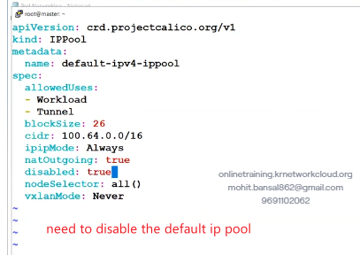

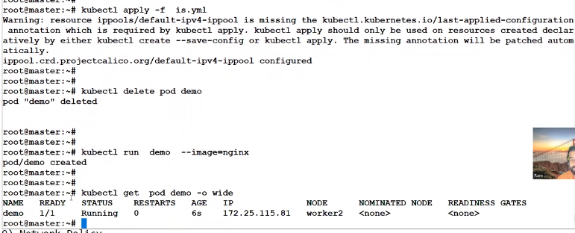

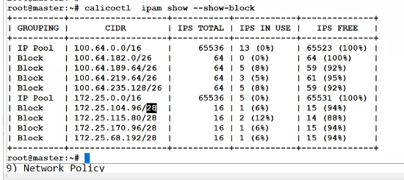

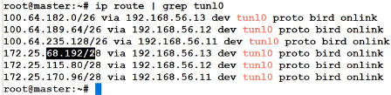

We can configure multiple subnet and tunnel will be only 1 and tunnel ip will be active pool

Enable the vxlan

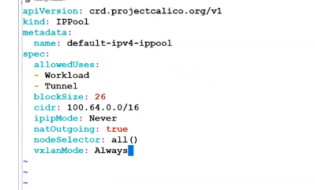

Two mode

Ipip

Vxlan

Service IP :

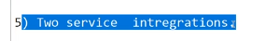

By default pod ip are not static and need to do the static

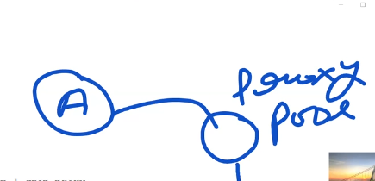

We have default proxy ip pool10.96.0.0./12 and that’s called service ip pool and service ip will be static and external will communicate with service ip and service ip to pod ( if pod ip will change the auto update/register the new ip with service ip mapping )

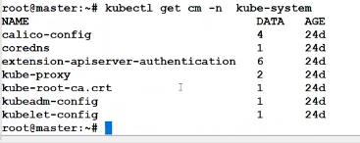

Service ip pool can change only the time of cluster creation.

Major case we not change the default service ip pool.

Kubernetes

Node pool

Pod pool

Service ip pool

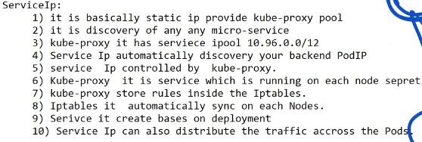

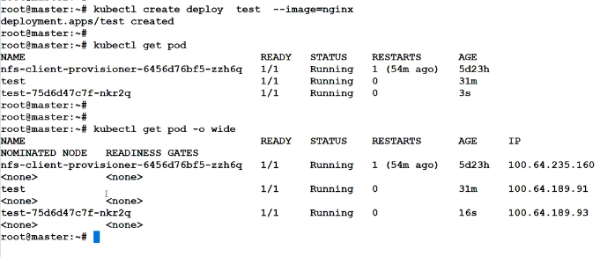

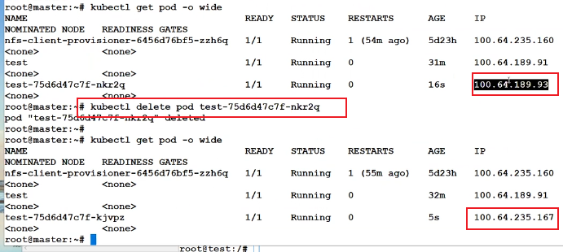

Now from one pod to another pod unreachable if use old ip

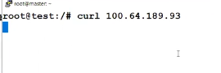

Will use now service ip ;

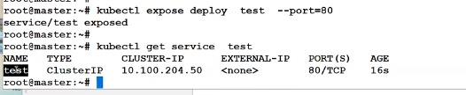

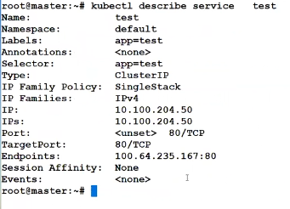

If delete and recreate the pod the ip will be auto update in service ip

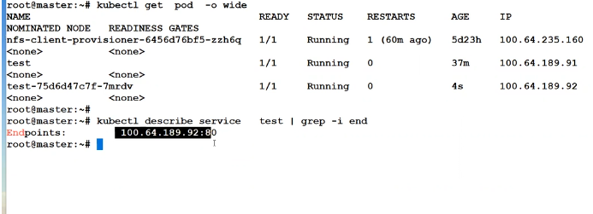

Iptable rules :

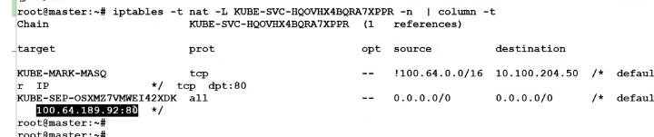

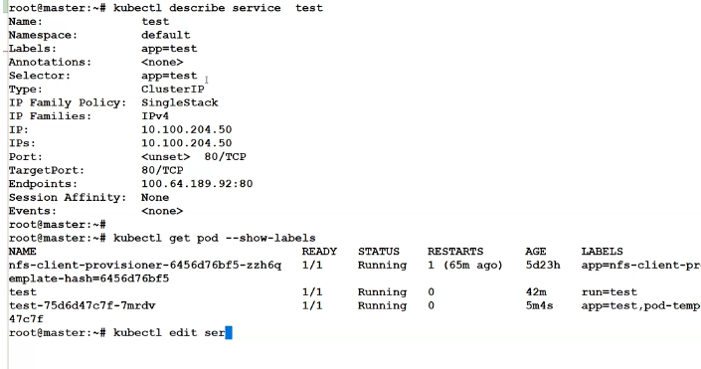

If service ip give the wrong selector value in that case pod end point will not mapped with service ip

Service ip query the pod ip with the help of level

Mean service ip level app=test and deployment pod level app=test

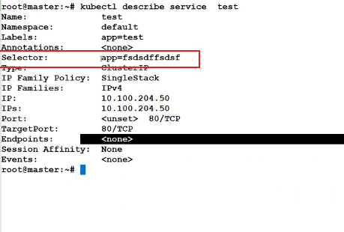

If deployment delete then service ip won’t delete.

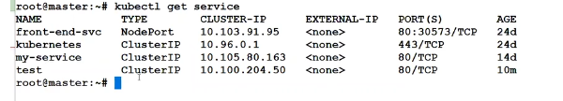

I create one pod ram and give the level app=test

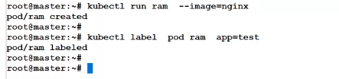

If service ip with app=test

In that case ram will map with service ip.

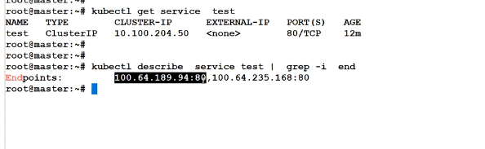

In that case mean 2 pod have same level app=test

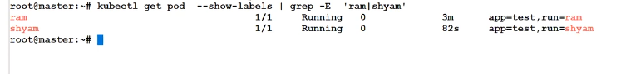

Service ip creation from yaml

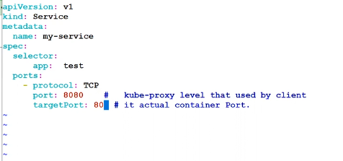

Command :



Core DNS:

In service ip name will be static and will use the name for deployment ( ip can change but not name)

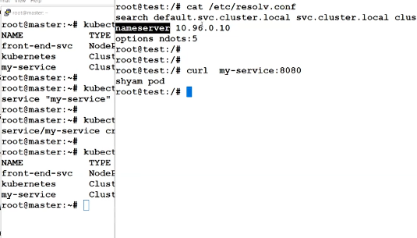

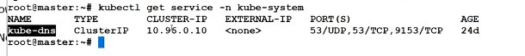

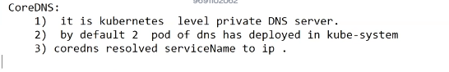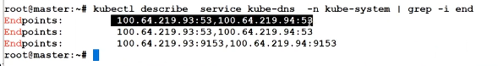

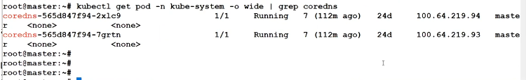

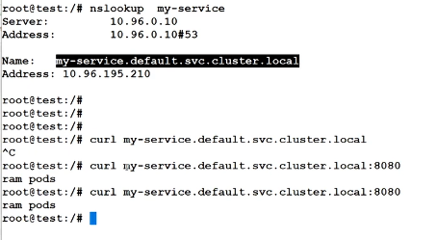

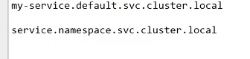

This is your internal private kube DNS server to reach the service internally with service name.

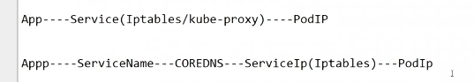

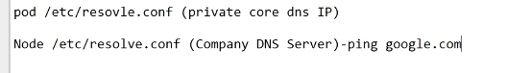

Node Port

External client to pod reach from the port forwarding - solution 1

From the ingress controller can reach the service from external network – solution 2

This is pod level port forwarding but not recommedended.

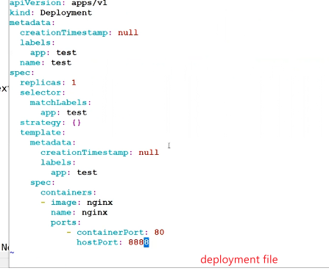

Port forwarding need to do on service ip/cluster ip level.

Port forwarding :

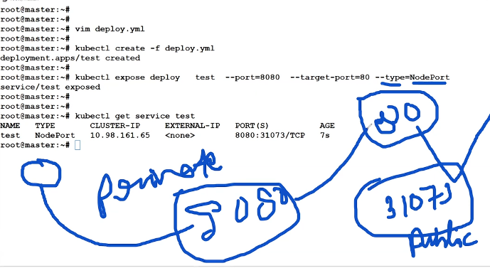

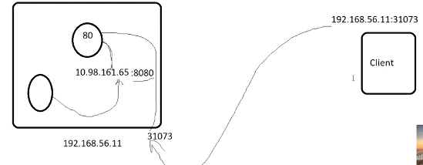

Internal kube-dns server at pod level only

For node level need to do the external DNS server

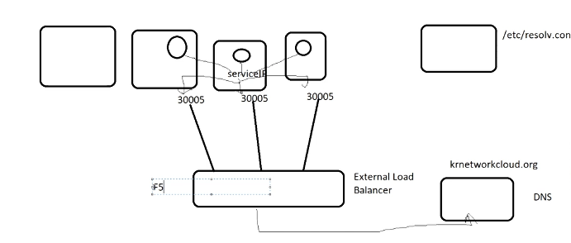

External load balancer removes post ingress controller solution.

HA Proxy as a external load balancer.

HA proxy Integration :

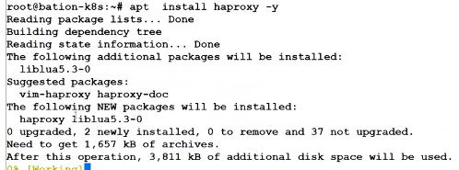

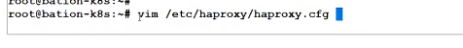

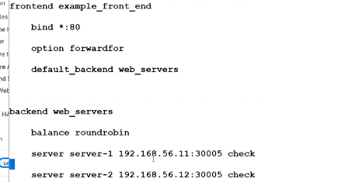

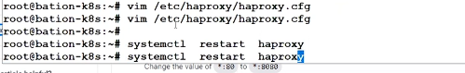

Base machine is HA proxy ip

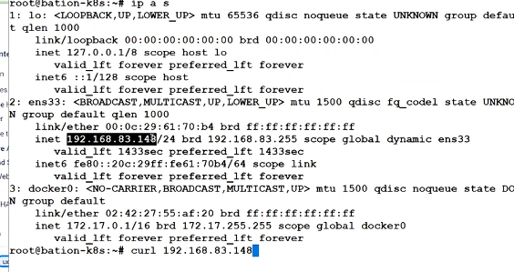



Network Policy :

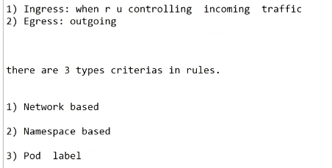

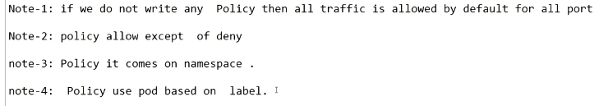

And

Or

Two type of critieria

In And both and all should match

In or only 1 should match out of all

**Service ip and network policy both work based on pod level**

LAB :

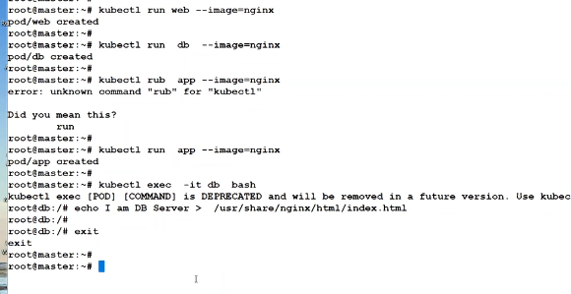

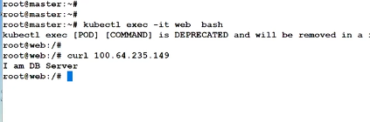

Internal pod can reach internally because no network policy and all allow by default.

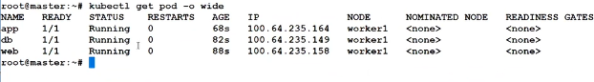

Network policy can write from manifest not by command.

Network policy creation now :

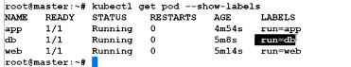

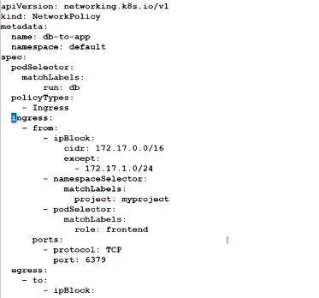

Ingress can do by subnet/namespace/pod level traffic allow.

We deleted subnet and namespace because don’t allow subnet level and source and destination pod in same namespace.

Name space will come if source and destination are diff namespace.

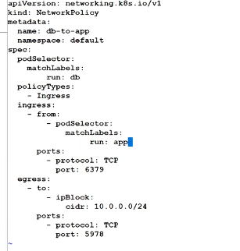

Policy are creating for db that’s why level run=db but allowing incoming traffic from app that’s why run=app

Final network policy :

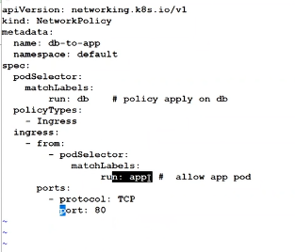

If create one more pod app with diff namespace then won’t allow

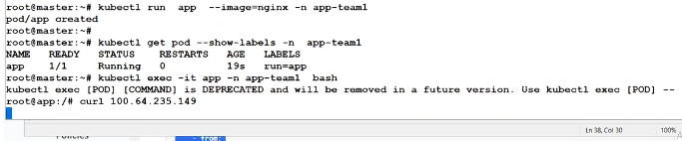

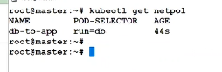

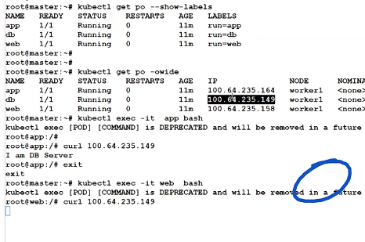



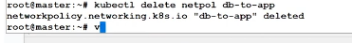

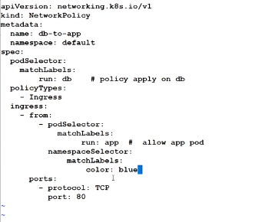

Need to give the label color blue in namespace app-team1



And critiera

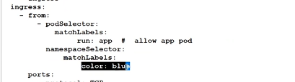

Or criteria

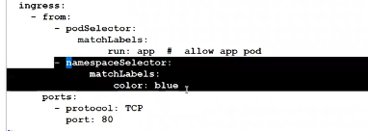



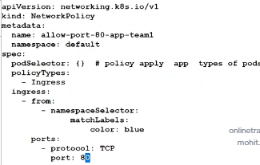

Ingress controller :

Why we need ingress controller

If use external balancer of AWS or any cloud then node port need to map again and again for each microservice and need to pay the port mapping cost and need to rememeber the node port for each service and path based routing issue

We create own load balancer at kubernetes level that’s called ingress controller which reduced such type of issue’s.

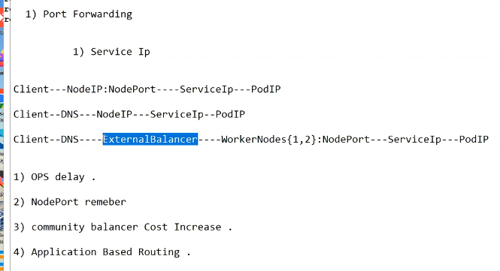

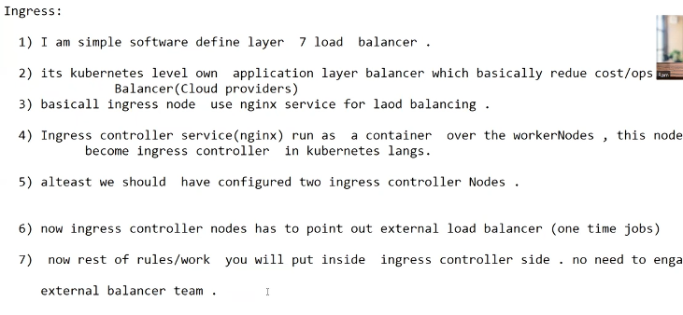

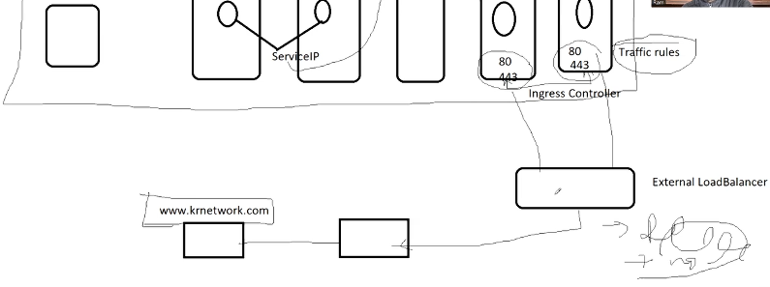

LAB:

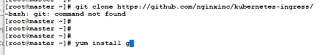

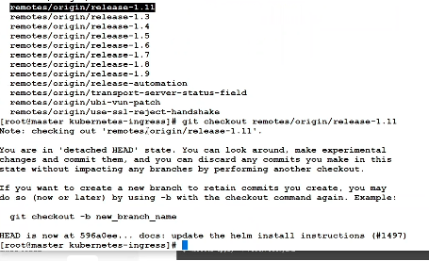

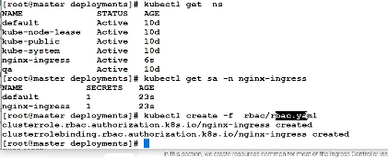

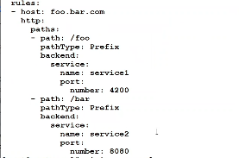

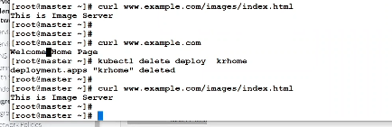

Volume :

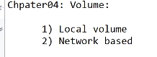

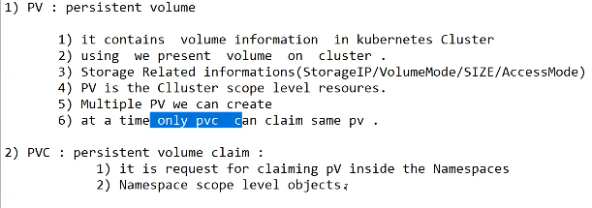

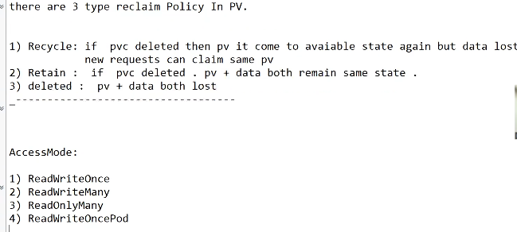

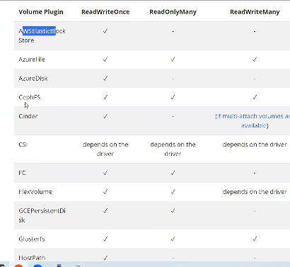

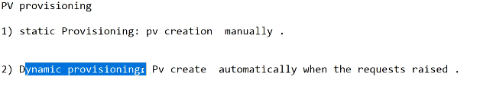

Create network based volume NFS server :

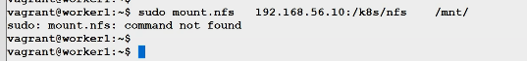

PV create :

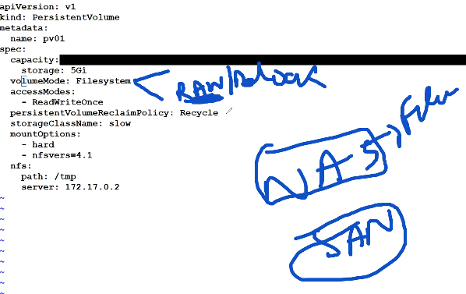

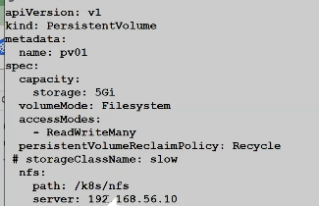

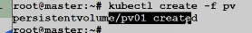



Status like available , bound, Released …

**PVC create**

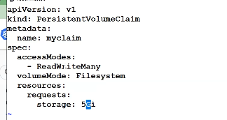

In PVC claim not giving the PV name but need to PV proprieties like access mode/ volume mode

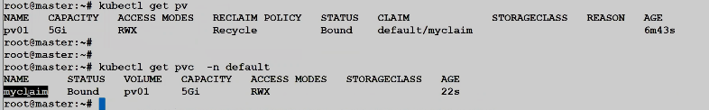

In deployment file we mapped the PVC with /usr/share/nginx/html

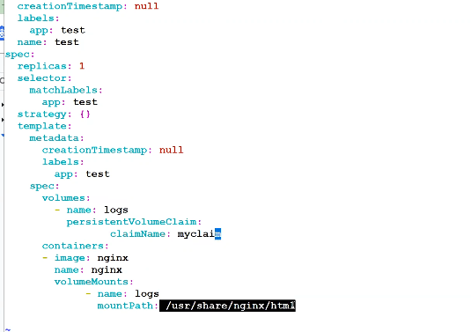

If pod delete and recreate again then data won’t loss

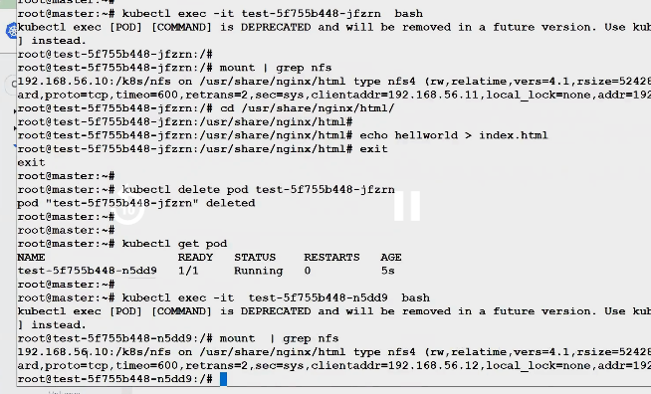

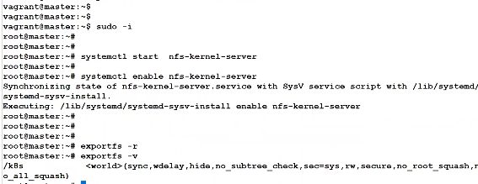

If deployment mapped with PVC then PVC can not delete

If PV mapped with PVC then PV can not delete

In retain type of PV need to remove old reference claim from the PV and need to claim again with PV then data will come auto in deployment with PVC claim name.

In one deployment map with multiple PVC volume

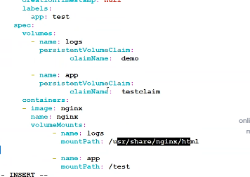

If have 2 PV with same size 5G then PVC how to decide PV01/PV02

Based on selector/label or storage class

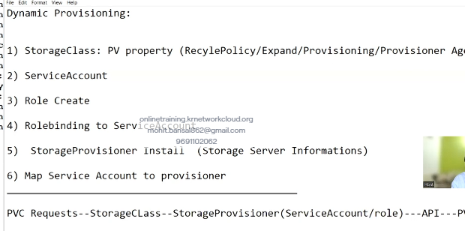

**Dynamic provisioning and local volume and CSI storage recording are pending**

RBAC : Resource Based access control

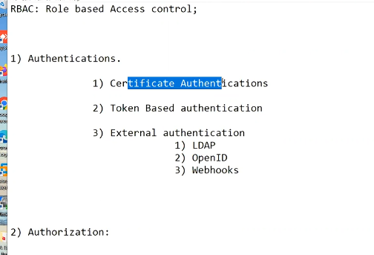

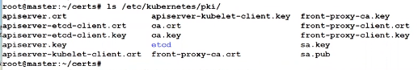

For certificate sign need below things:

* Auth sign
* Private key

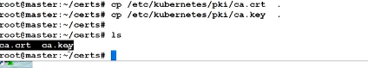

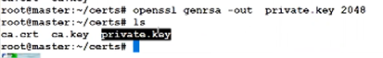

Private key---------------CSR-------------------CRT

Creating the CSR



CRT created



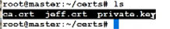

Kubernetes default authentication file

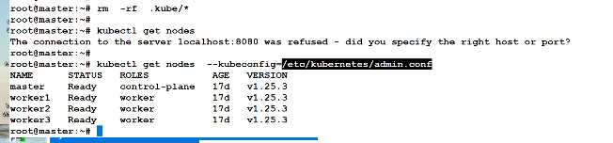

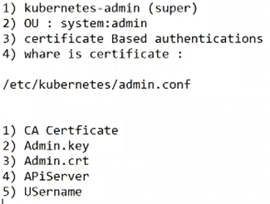

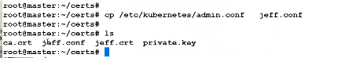

Creating jeff.conf for bastion node

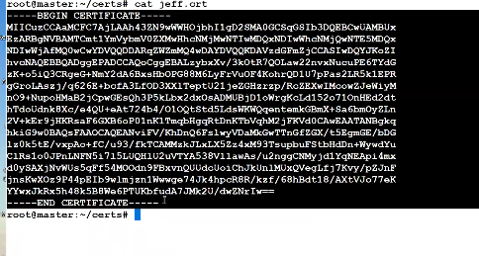

Need to convert first base64 format

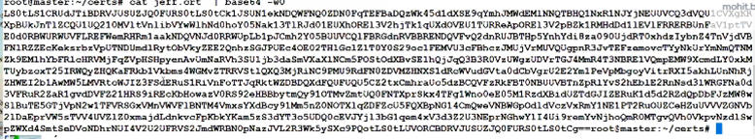

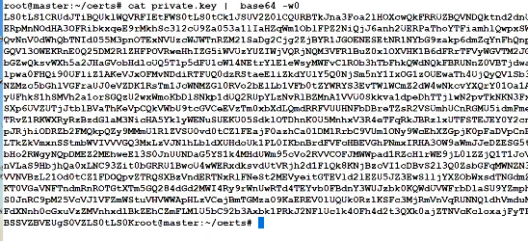

Copy the key and crt

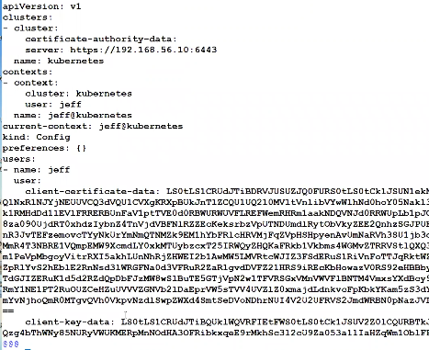

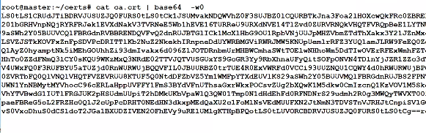

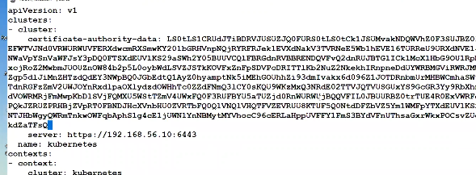

Copy the jeff.conf in normal ubuntu bation node

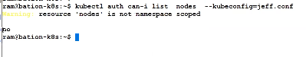

**RBAC part 2**

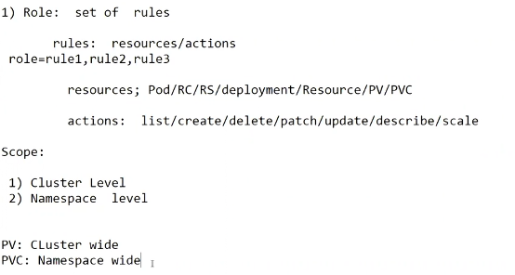

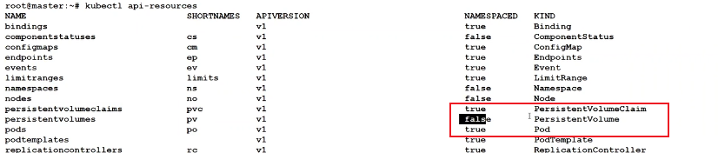

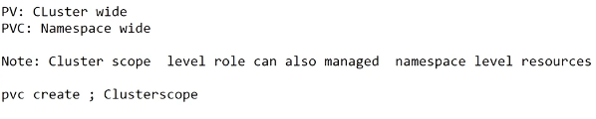

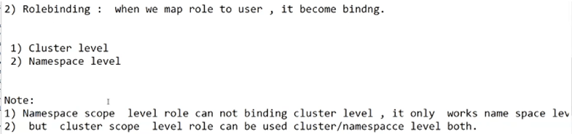

**By default cluster role binding in system and can create the custom role as well**

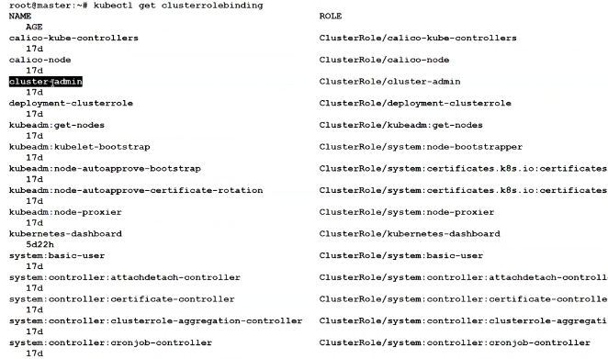

LAB:

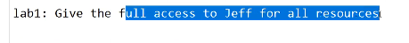

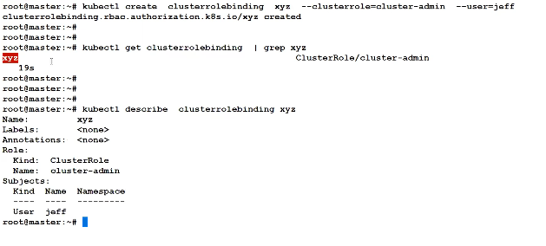

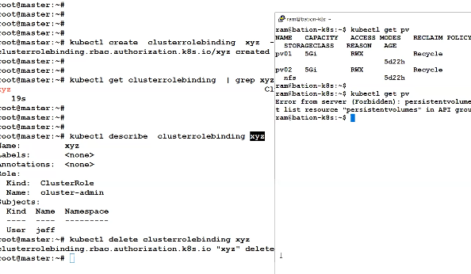

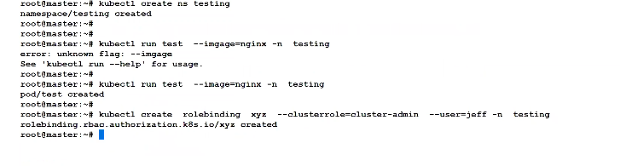

Now command will run on specific namespace testing only

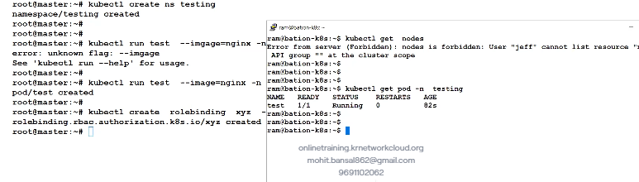

On group

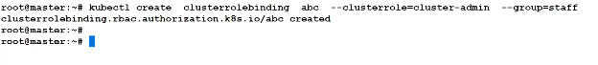

Same name can give multiple namespace

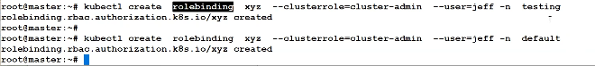

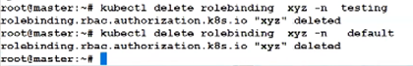

Service account :

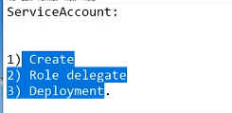

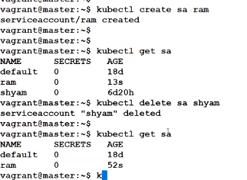

Service account ram to give cluster-admin permission

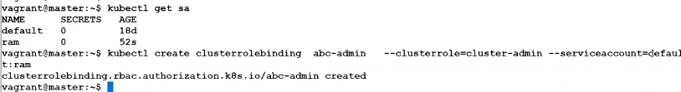

In deployment need to give service account :

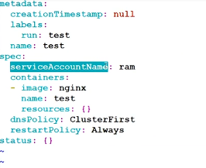

Now pod work as bation node and can run the kubectl command :

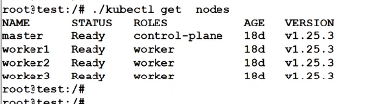

Now password protected image need to pull



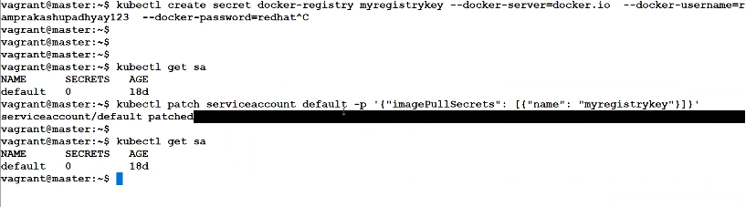

In service account file can edit also imagepull secret

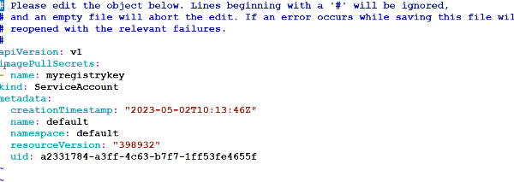

In deployment need to give the service account name then image can pull.

Auto scalling :

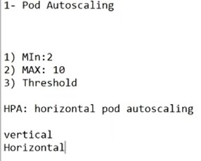

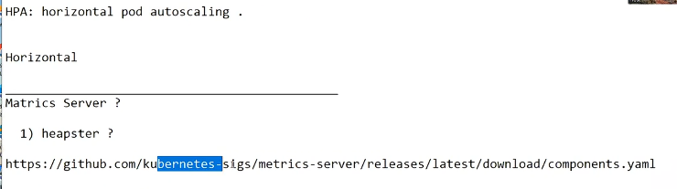

Metric server creation:

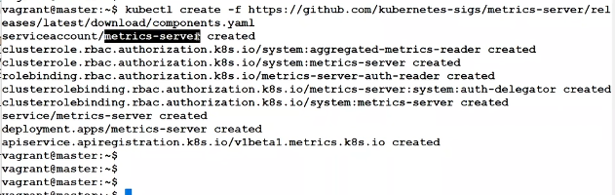

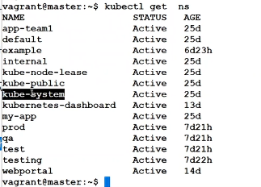



Edit the metric server deployment and add the tls line

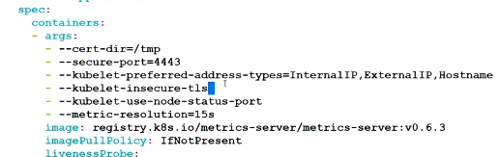

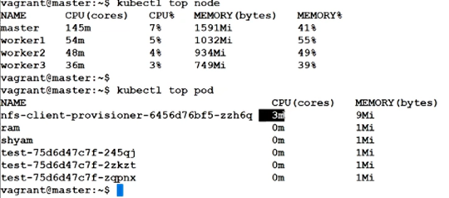

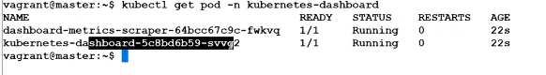

Metric server dashboard :

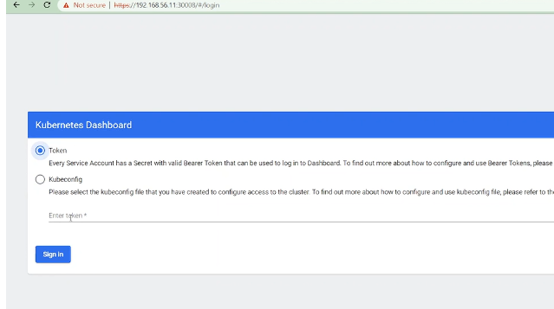

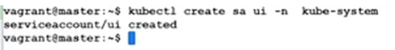

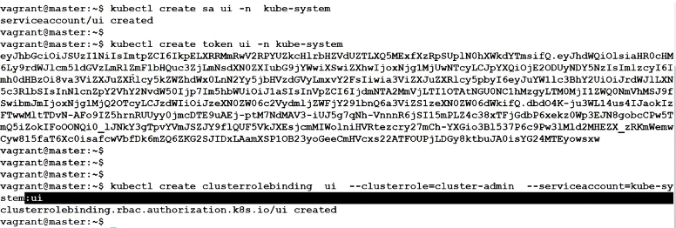

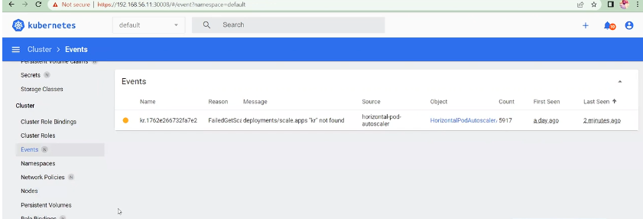

etcd backup and restore:

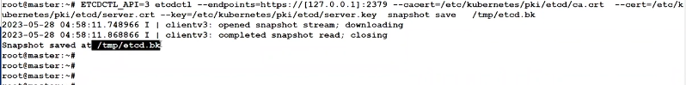

Secret :

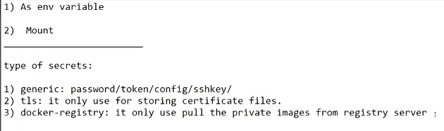



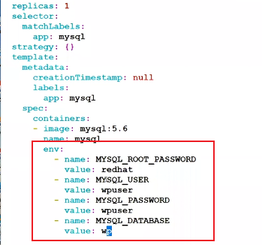

By command :



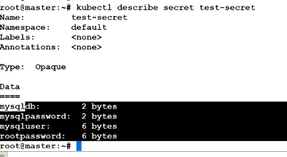

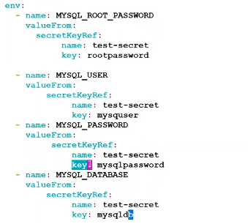

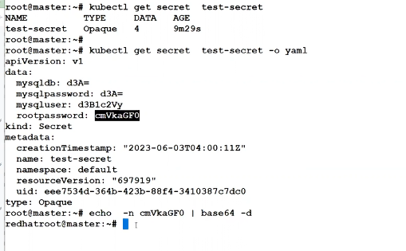

Config map

In config map will keep the data plain text format like proxy ip and other information which can not hard code in image and can pass such information to container with the help of config map

In secret will keep the sensitive information like password username as encrypted format.

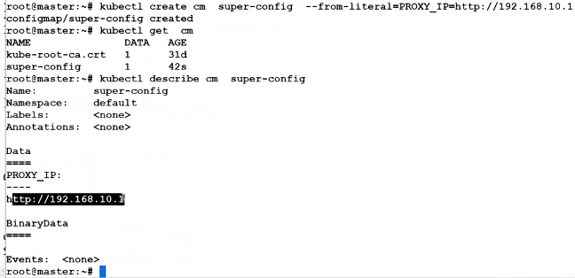

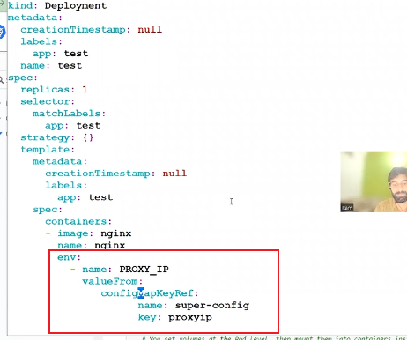

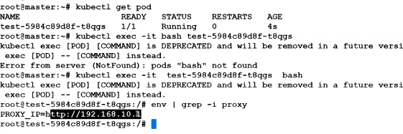

Config map with 2 section

1. Env
2. Volume



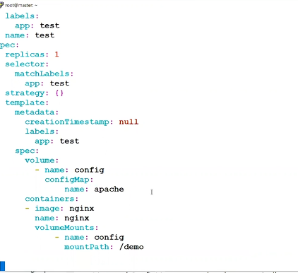

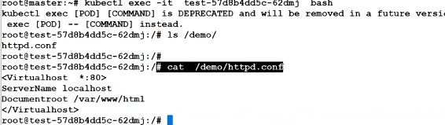

Dameon Set also is pod controller.

If u want to install motioring agent each worker node that surety will give deamon set

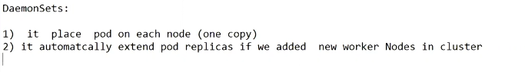

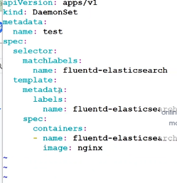

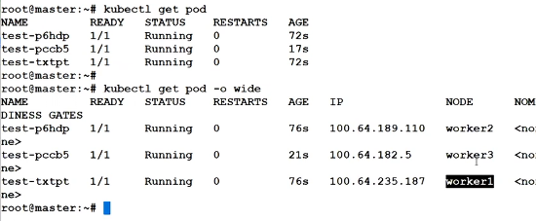

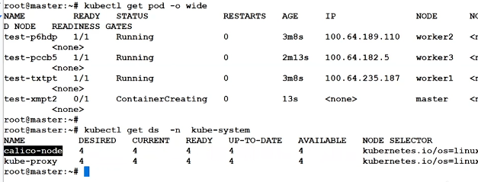

Statefull and stateless deployment :

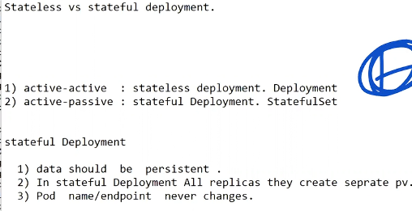

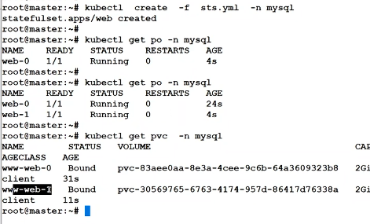

In stateless will be Service ip

In satate full deployment will be headless ip

**Class-6**

**Volume: -**

1. Local Volume

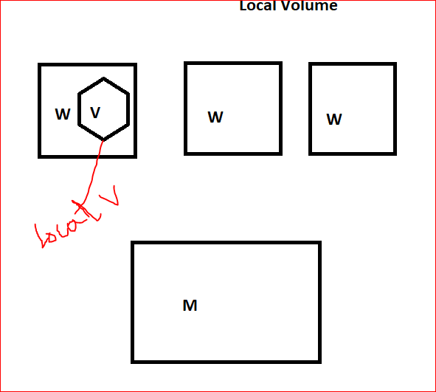

1. Network based Volume. (NFS Server)

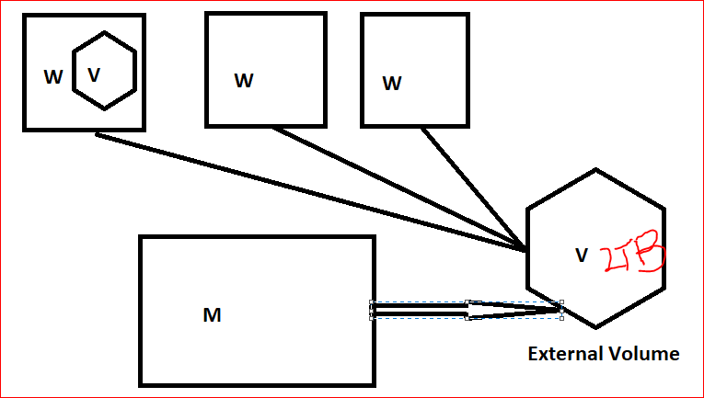

API Volume Resources.

1. PV: Persistence Volume

* It Contains Volume Information in Kubernetes Cluster
* Using we present volume on cluster.
* Storage Related information (StorageIP/VolumeMode/Size/AccessMode)
* Multiple PV we can create.
* At a time only PVC can claim same PV.

1. PVC: Persistent Volume claim:

* it is request for claiming PV inside the namespace.
* Namespace scope level objects.

There are 3 types of reclaim Policy in PV:

* Recycle: if PV delete then PV come to availablestate, but data lost

new request claim in same PV

* Retain: if PV delete. PV + Data both remain same state.
* Deleted: PV + Data Both lost

Access Mode:

* ReadWriteOnce
* ReadWriteMany
* ReadOnlyMany
* ReadWriteOncepod

Note: PV Access Mode Depends(ReadWriteOnce&ReadWriteOncePod) on application Architecture for ex- mysql

PV Provisioning:

* static Provisioning: PV creation manually.

PV request raised and setup PVlater.

* Dynamic Provisioning: PV create automatically when the request raised.

PVC--Agent--PV create automatically.

2 types of PV Create in Kubernetes:

* Static Provisioning: PV request raised and setup PVlater.
* Dynamic Provisioning: PV create automatically when the request raised.

PVC--Agent--PV create automatically.

1. Storage Class: PV Property (Recycle Policy/Expend/Provisioning/Provisioning agents)
2. Service Account
3. Role Create
4. Role-binding to Service Account
5. Storage Provisioning Install (it contains storage server information)
6. Map Service account to provisioner.

LAB: -

Install NFS Server: - Search On google how to install NFS server and install in one of you VM.

After Install Create directory and give them permission.

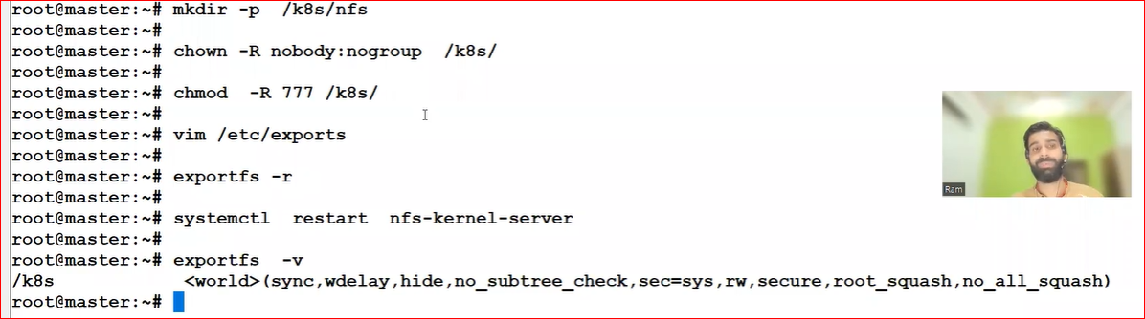

Before NFS attach with worker node avoid firewall issue.

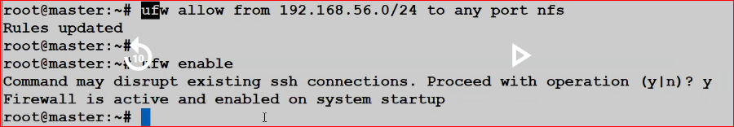

Note: Pls Don’t enable ufw otherwise your worker node will not reachable

Now NFS attach with Worker Node.

Login worker node: -

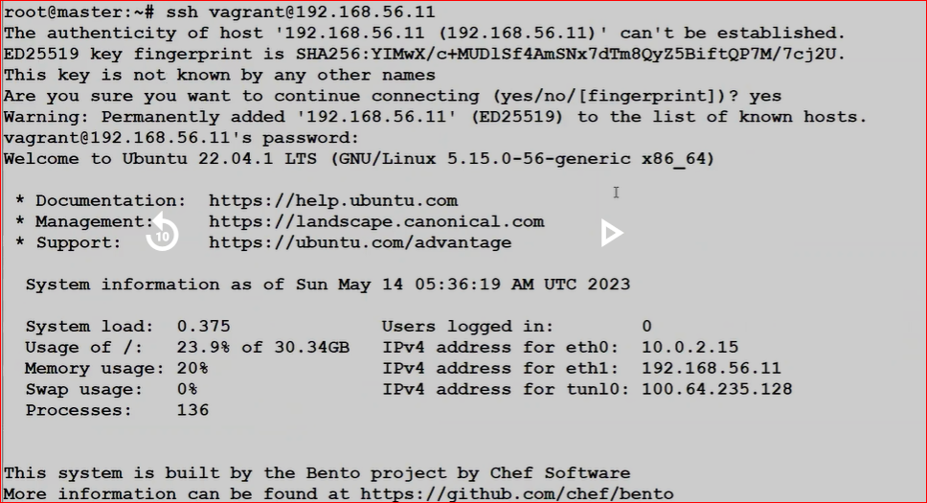

Install NFS Agent on worker node.

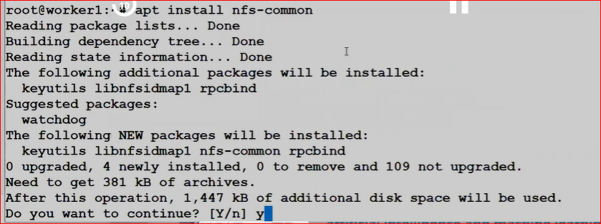

Mount NFS on Worker node: -

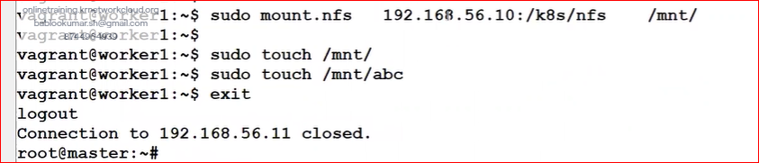

After write data on worker node and verify data available of NFS server or not, after verify you can unmount.

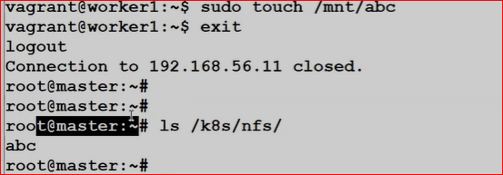

Unmount from worker node1.

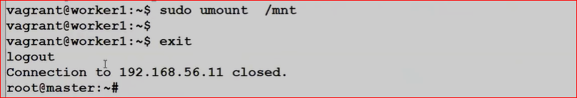

Note: same process follows other worker node because some time pod create on other worker node also.

Lab: - Static Provisioning: we can’t expend volume in static provisioning

Now create 1st PV

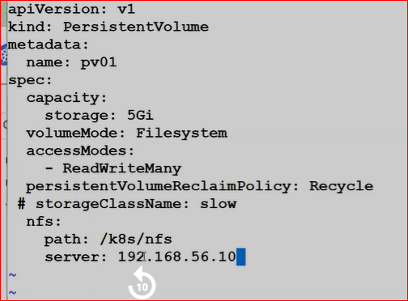

Note: - 2 Type of Volume-Mode

1. Filesystem: if upcoming storage is NAS Category
2. RAW/Block: if Upcoming Storage is SAN Category

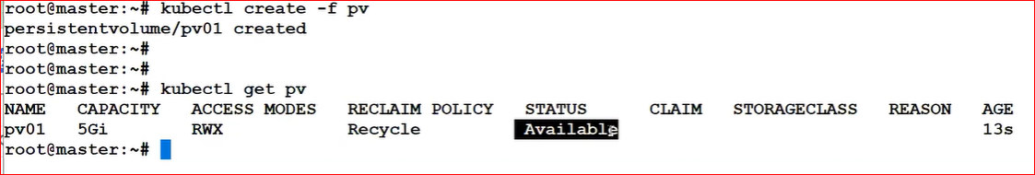

Q. How many types of status in PV.

A. 1) Available

2) Bound

3) Released

4) Failed

Note: if you want claim PV its call PVC (Persistent Volume Claim)

Vi pvc

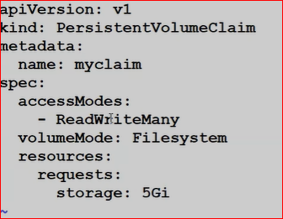

When you claim PV. PV status and Claim will change.

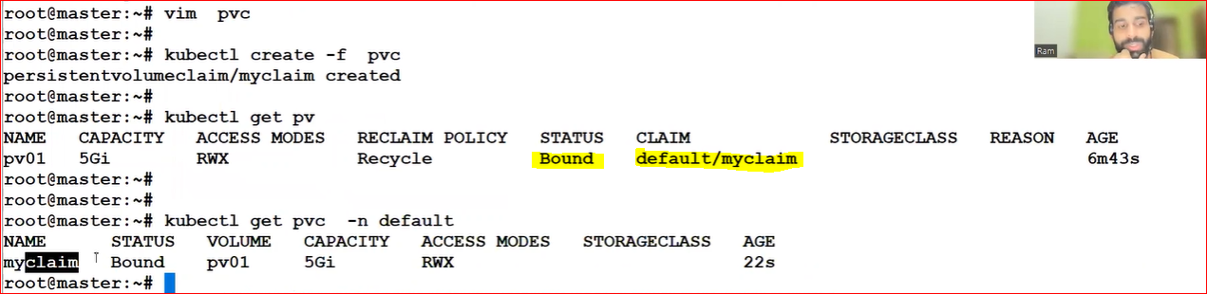

Start Deployment with PV



Declare Volume in Deploy yaml:

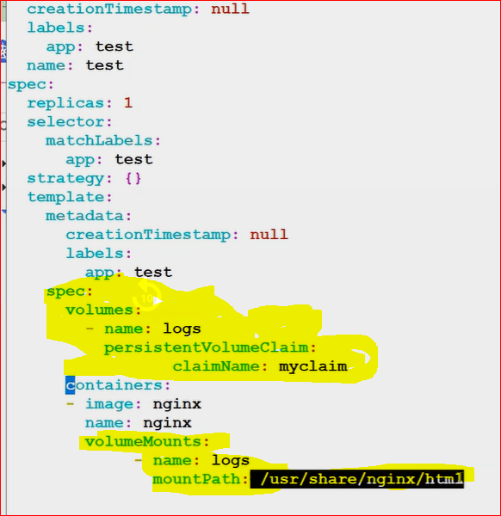

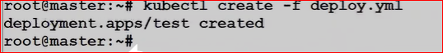

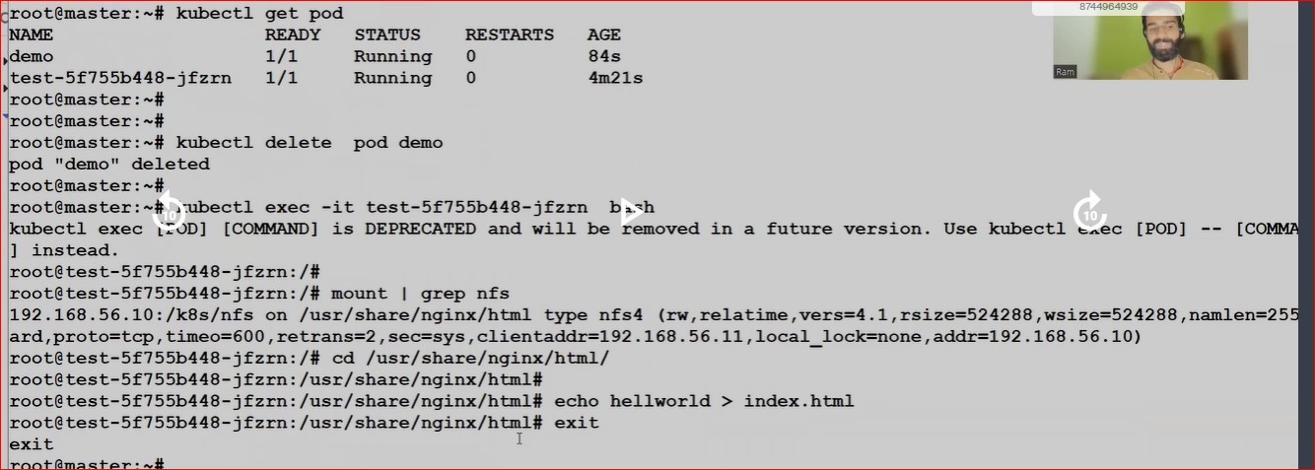

After Deleting the POD still your data is remain.

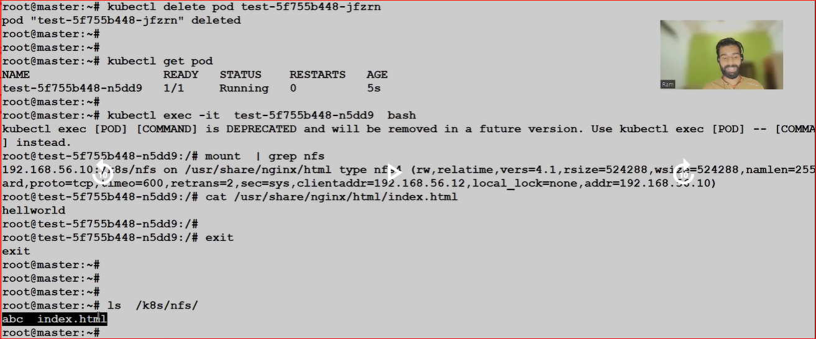

**Class-9**

ingress (Inbound Network)allow incoming traffic.

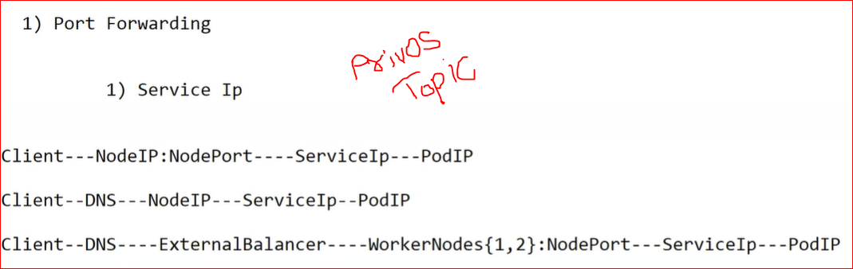

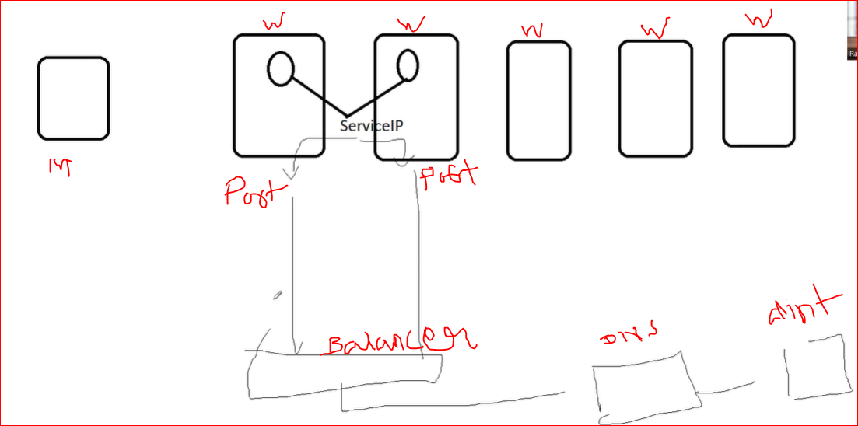

Issue on above scenario:

1. OPS(Operational) Delay.
2. Need to Remember Node Port.
3. Community Balancer Cost Increase.
4. Application Based Routing(it means not sure traffic going on which application)
5. **Ingress Controller Explanation: -**
6. I am simple software define layer 7 load balancer.
7. Its Kubernetes level own application layer balancer which is basically reduce cost /ops of community Balancer (Cloud Provider)
8. Basically, Ingress node use nginx service for Load Balancing.

For ex: Nginx(they help to host web and load balance also)

1. Ingress Controller service(nginx) run as a container over the worker node, this node become ingress controller in Kubernetes language.
2. At least we should have configured two ingress controller Nodes.
3. Now ingress controller node has to point out external load balancer (one time job)
4. Now rest rule/work you will put inside ingress controller side. No need to engage external balancer team.

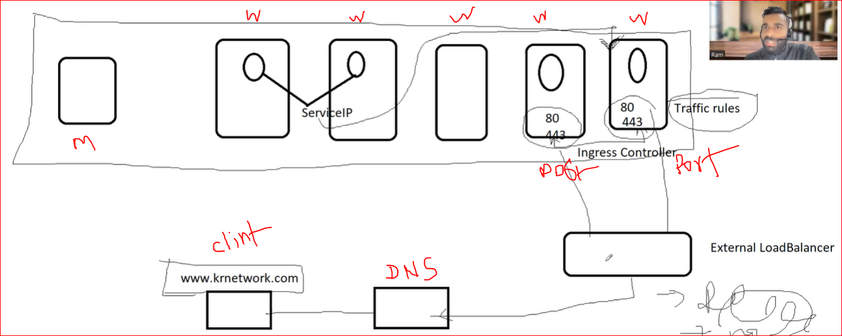

**LAB: -**

1. Search on google how to install ingress controller in Kubernetes.

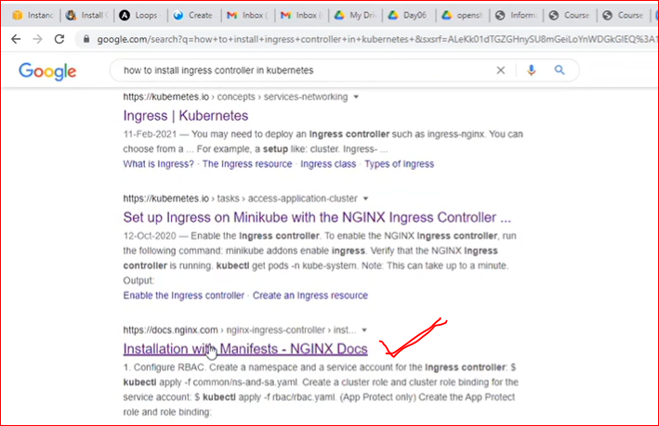

Note: - for ingress installation please follow website doc instruction.

Please uncomment last setup in yaml file

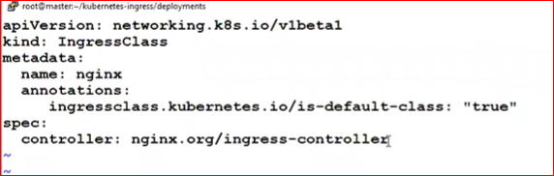

Now ingress class is created.

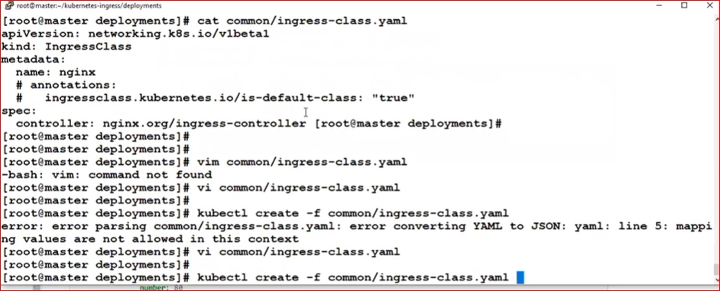

After done above installation than deploy your pod.

* Edit your deployment yamlother wise ingress controller take calico NW IP

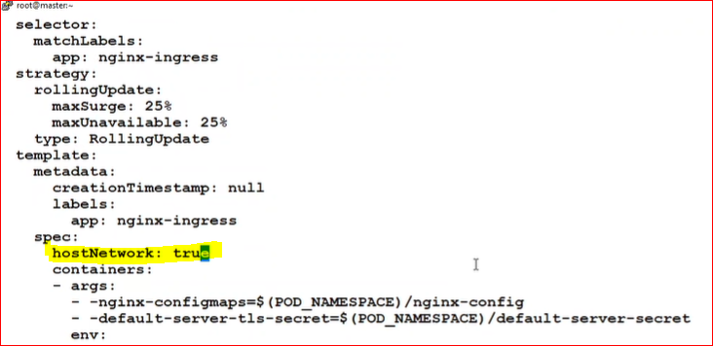

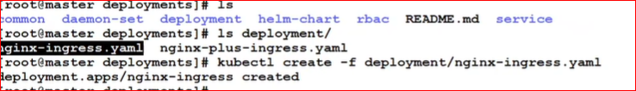



* How to Configure Ingress Rules

1. Deploy new website.

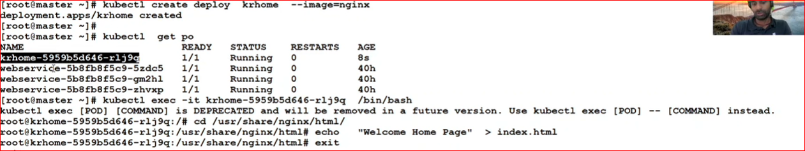

1. Expose service IP for new deployment.

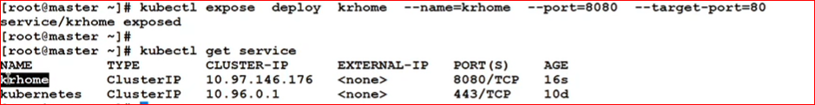

1. Configure Ingress rules respective of new service IP.

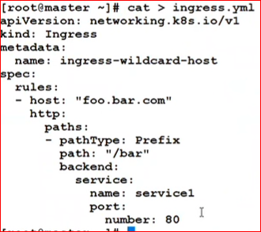

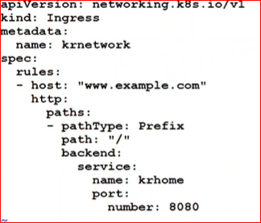

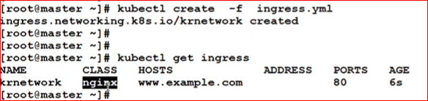

Now, we don’t have balancer so we do one thing go to vi /etc/hosts ingress ip and domain name

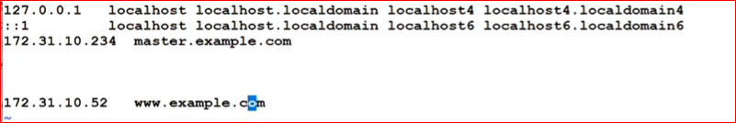

o/p

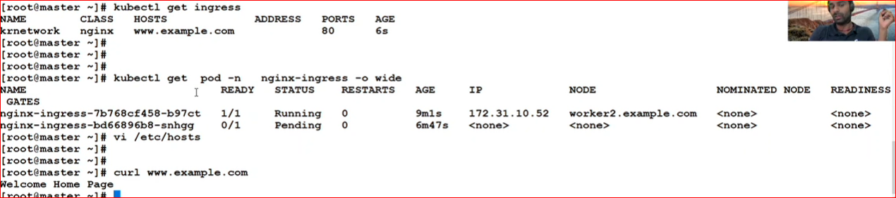

**Class-10.**

* **Pod Autoscaling**

There are 2 type.

1. Horizontal
2. Vertical
3. In Kubernetes, a HorizontalPodAutoscaler automatically updates a workload resource (such as a [Deployment](https://kubernetes.io/docs/concepts/workloads/controllers/deployment/) or [StatefulSet](https://kubernetes.io/docs/concepts/workloads/controllers/statefulset/" \t "_blank)), with the aim of automatically scaling the workload to match demand.
4. MIN: 2
5. MAX: 10
6. Threshold

Resource to use in auto scaling**.**

HPA: Horizontal pod autoscaling

Note: - HPA is a rule that define in hipster, Prometheus Metrics server

Based on Metrics server HPA are executed.



Note: - above git hub are link to deploy hipster on Kubernetes.

Copy above link and deploy on master node.

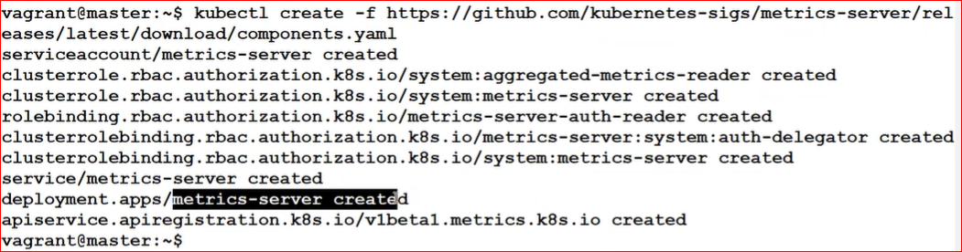

By default, deployment goes in tokube-system namespace



**Note:** - if you get the error regarding https then edit your yaml update http rule and deploy again



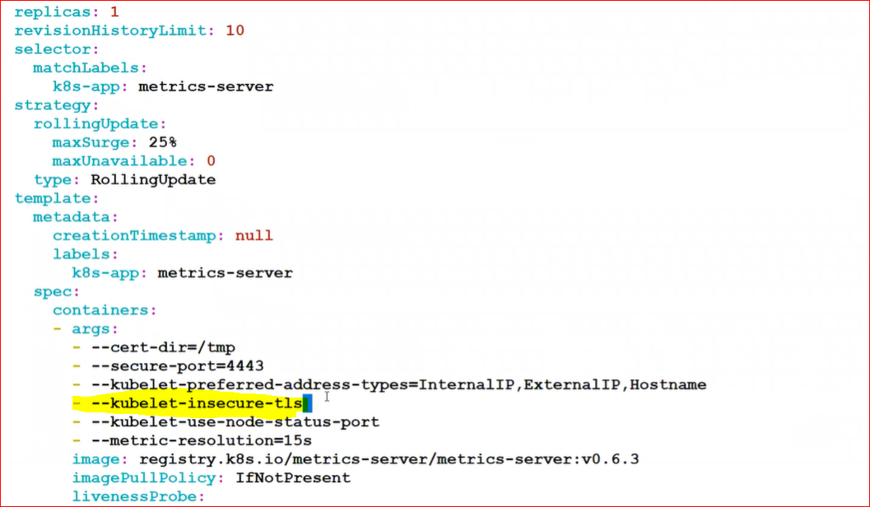

**If you check traffic utilization there are 2 type GUI and Command line**

1. **Check Through Command line**

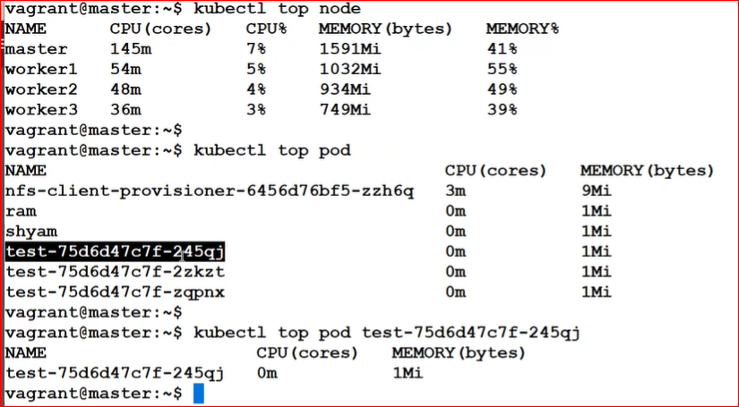

1. **Check through GUI**

**Deploying the Dashboard UI from Kubernetes doc**

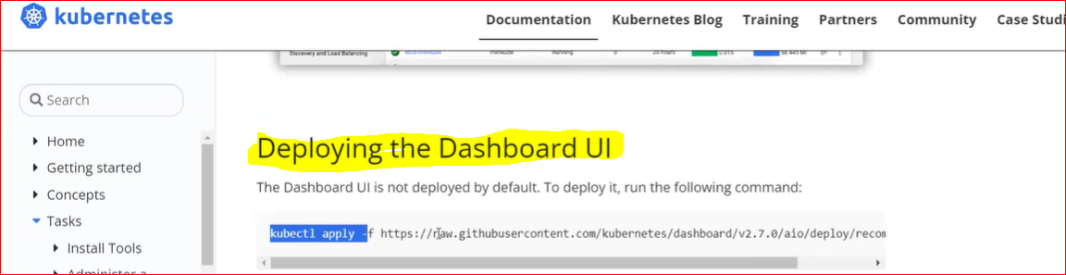

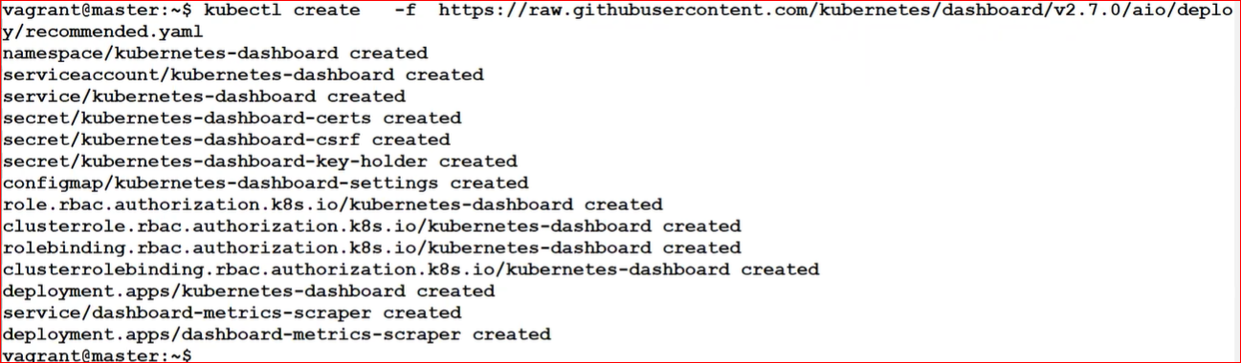

Note: - for GUI Dashboard Kubernetes make separate namespace

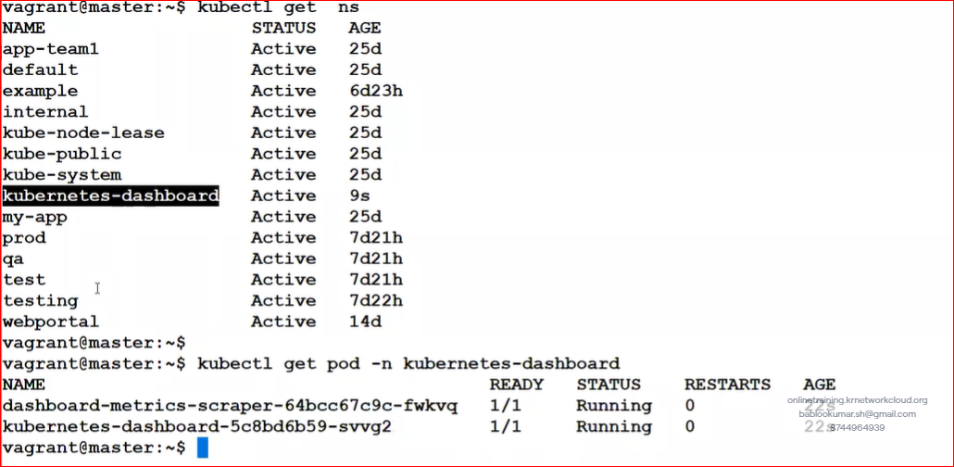

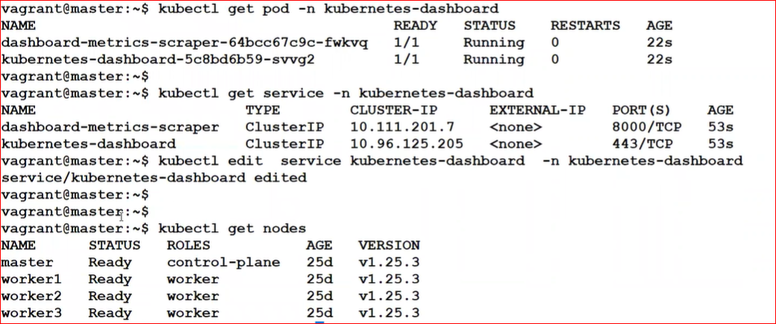

Here we expose service IP to access from GUI

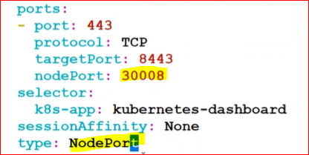

Now we access below any service IP with Port no from GUI

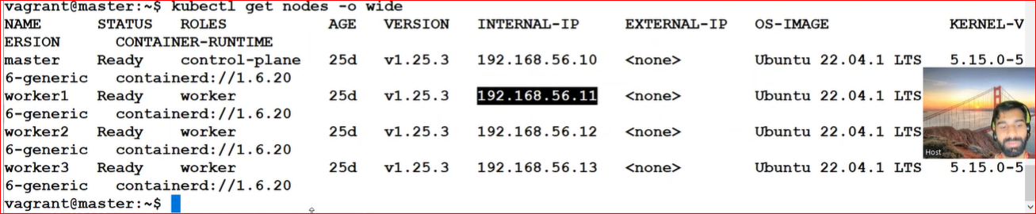

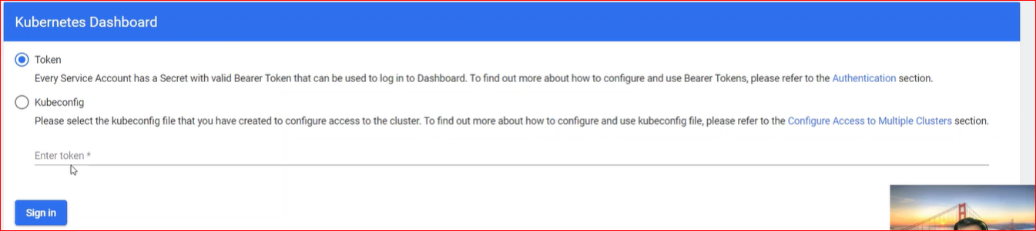

For token we need to create service AC /authentication and authorization

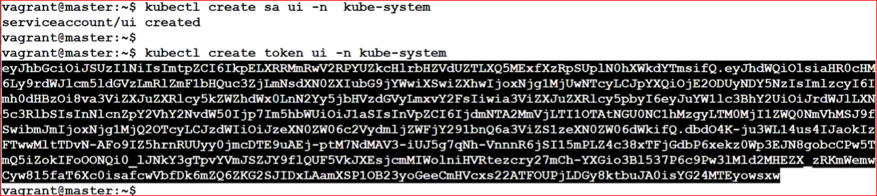



Now you able to see all things from GUI

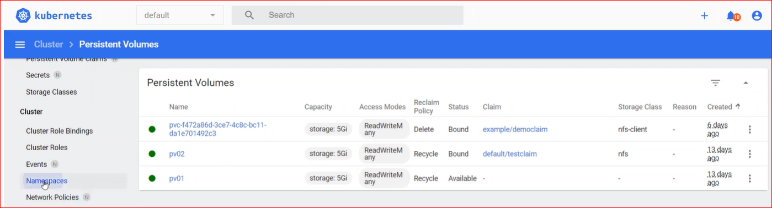

Now Perform HPA Rule

Copy manifest from Kubernetes website.

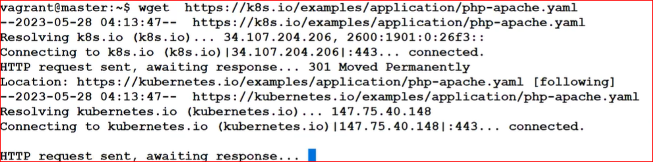

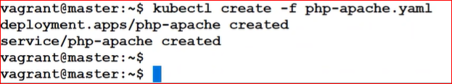

Create auto scale rule.





Open 3 windows

Check HPA

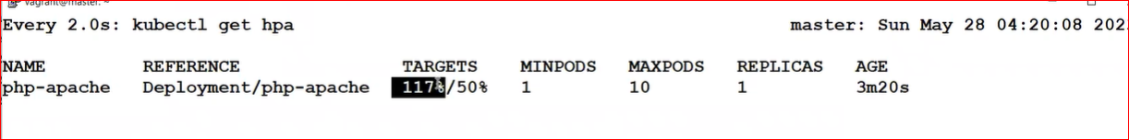

Auto pod creation

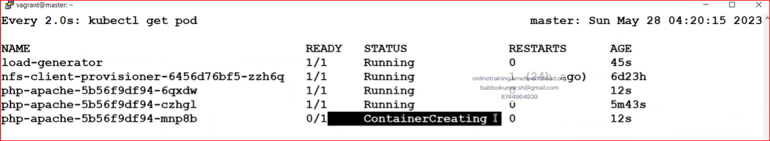

Apply load

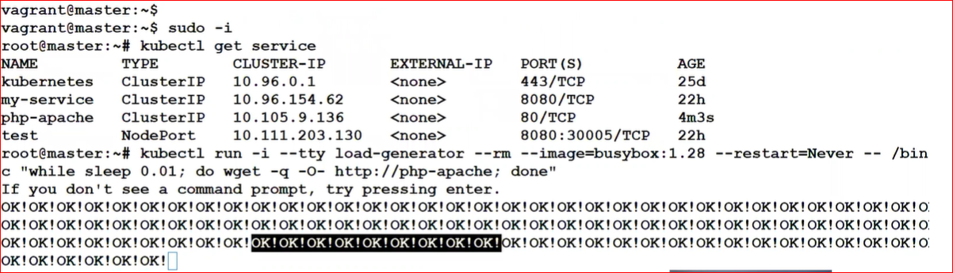

* **etcd Backup and Restore**

1. **Individual backup: -** take yaml backup on git hub
2. **etcdbackup:-**for etcd backup need certificate

etcd backup path:- ls /etc/kubernetes/pki/etcd

for backup below 3 are important

ca.crt, ca.key, server.crt



Before backup need to install in your system.

1. **Utility: etcdctl**
2. **URL: port number**

ETCDCTL\_API=3etcdctl --endpoints=https://[127.0.0.1]:2379 --cacert=/etc/kubernetes/pki/etcd/ca.crt \

--cert=/etc/kubernetes/pki/etcd/server.crt --key=/etc/kubernetes/pki/etcd/server.key \ snapshot save <location of backup>

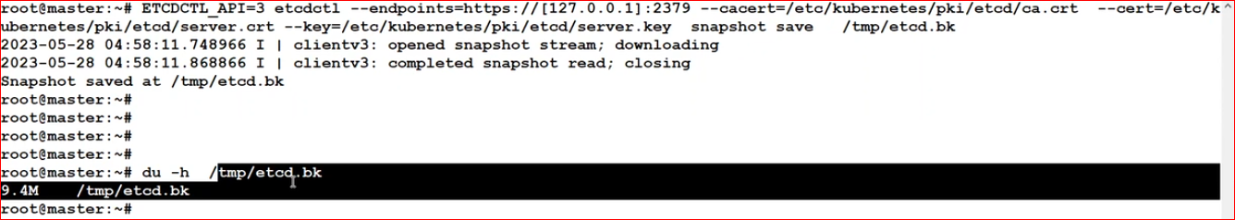

**Backup-Restore:-**

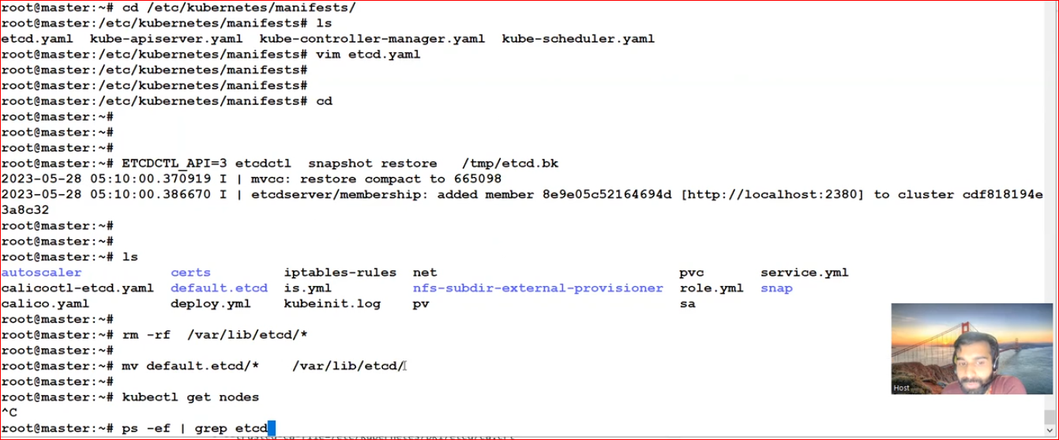

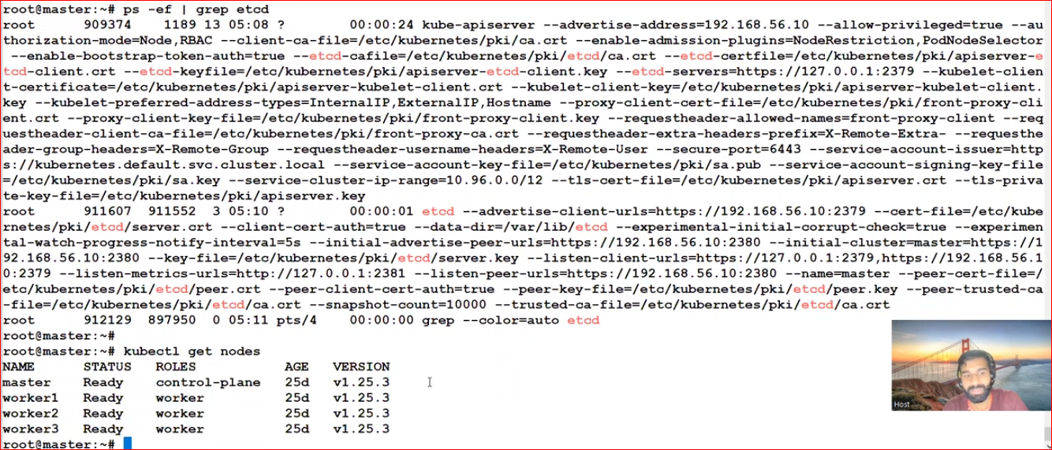

**Class-12**

* **Secret**

A Secret is an object that contains a small amount of sensitive data such as a password, a token, or a key. Such information might otherwise be put in a [Pod](https://kubernetes.io/docs/concepts/workloads/pods/) specification or in a [container image](https://kubernetes.io/docs/reference/glossary/?all=true#term-image). Using a Secret means that you don't need to include confidential data in your application code.

Uses of Secret: -

1. Environment Variable
2. Mount

Type of Secrets: -

1. Generic: - Password/token/config/sshkey
2. Tls: - it only uses for storing certificate Files.
3. Docker-Registry: it only uses pull the private image from registry server.
4. Generic:

Lates create yaml deploy the pod and check sensitive info showing as it: -

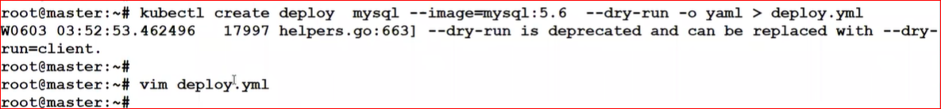

After creating yaml file edit and change sensitive info.

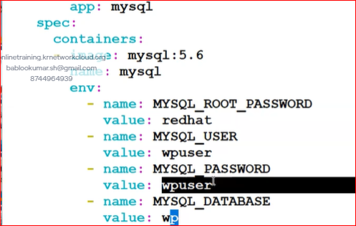



**Create Secretsobject**: -

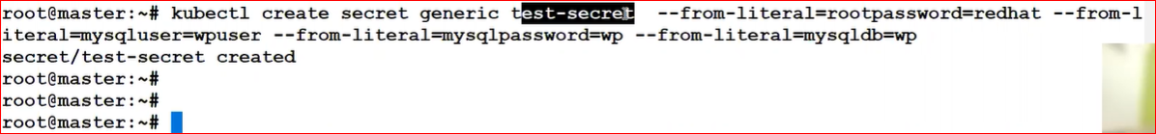

Note: - here generic is type of secret and test-secret name of secret and –from-literal=rootpasswrd=redhat is sensitive info which you need make encrypted format.

Now, as root user you can access secret data.

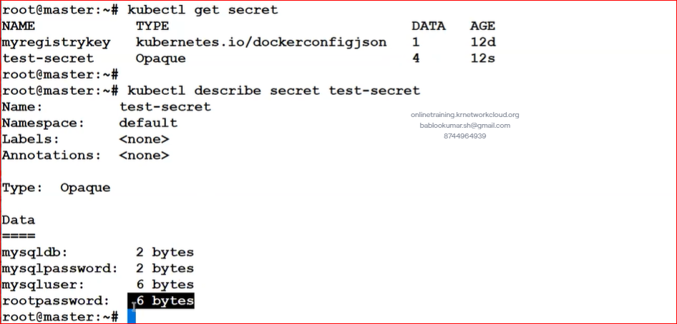

**How to use secretes in deployment**: -

Vi deploy.yaml and change the value call from secret object

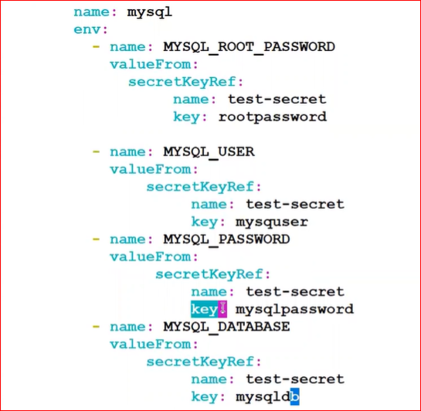

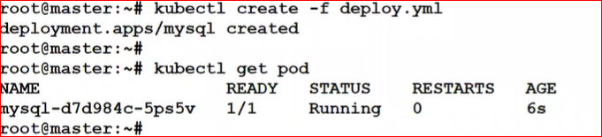

Kubectl describe deploy mysql

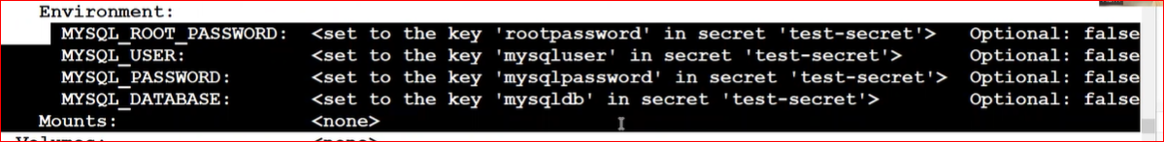

Q. if I forget database password then how can I recover it.

A. Loging as super user and d-crypt your secret with below command

echo -n cmVkaGFO | base64 -d

Example-2: -

Mount🡪



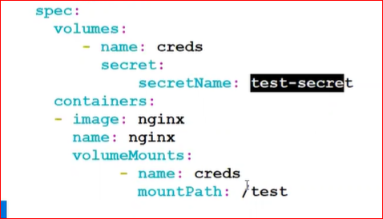

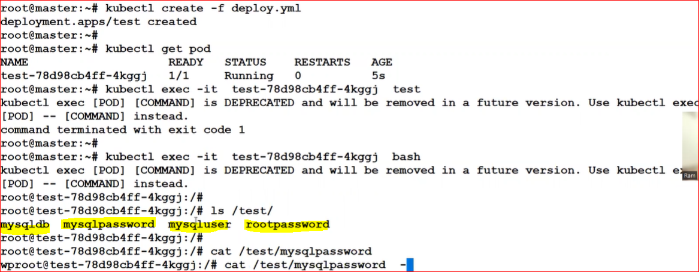

How to login mysql in container

Kubectl exec -it <pod id> bash

mysql -u root -p and password

==========================================================================

**B. TLs: -**

Mkdir certs

#openssl req -x509 -sha256 -nodes -days 365 -newkey rsa:4096 -keyoutprivate.key -out certificate.crt

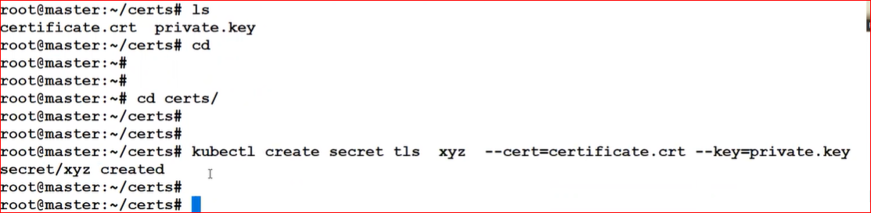

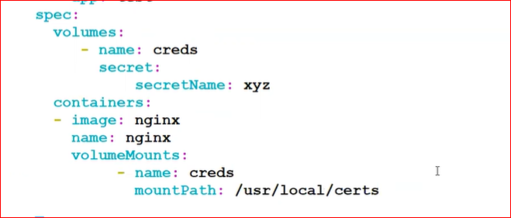

------------------------------------------------------------------------------------------------------------------------------------

**Config-Map**: -

configmap is same as secret and hold is value in text form while secret hold value in encrypted (base64) form.

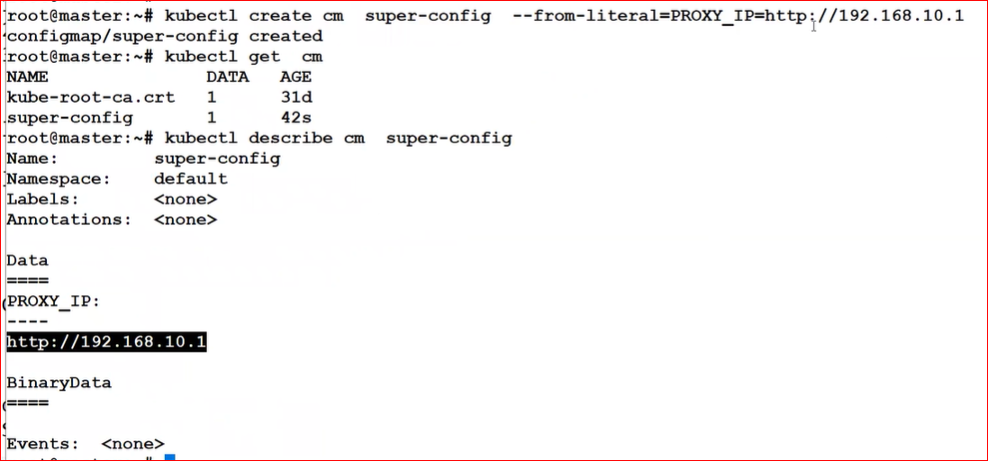

Create Deployment: -

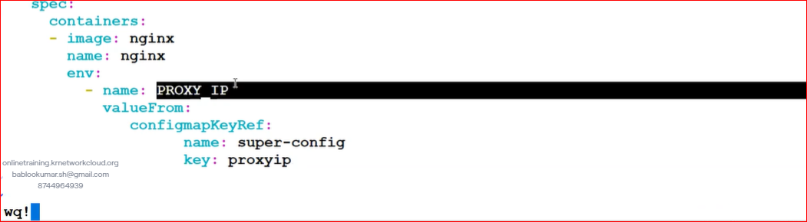

Q. what is difference b/w secretes and configmap

A. if the vale is sensitive then I will use secretes and if the vale is not sensitive then we will use configmap.

**Daemon Set**: -

1. It places pod on each node (one Copy)
2. It automatically extends pod replicas if we added new worker Nodes in Cluster

Vi ds.yaml

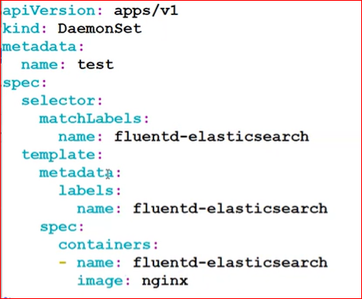

~~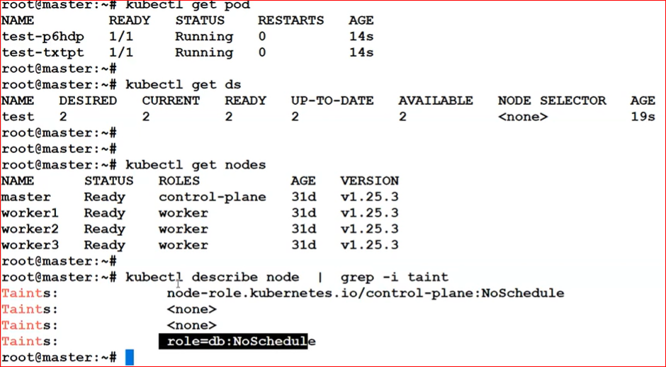~~

In this case our one worker node is taint that’s why ds running on 2 worker node

After untaint node now running on all 3 nodes.

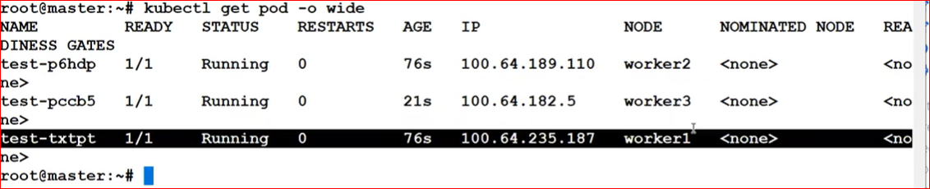

==========================================================================

Stateless &Statefull Deployment: -

1. Active-Active 🡪 in Kubernetes called Stateless Deployment : Service IP
2. Active-Passive 🡪 in Kubernetes called Stateful Deployment : Headless Service
3. Stateless Deployment: -
4. Stateful Deployment: -
5. Data should be Persistent.
6. In stateful Deployment All replicas they create separate pv.
7. Pod name/endpoint never changes. (now we can enable replication between the pods)
8. Pod Creation and startup order always in sequence.

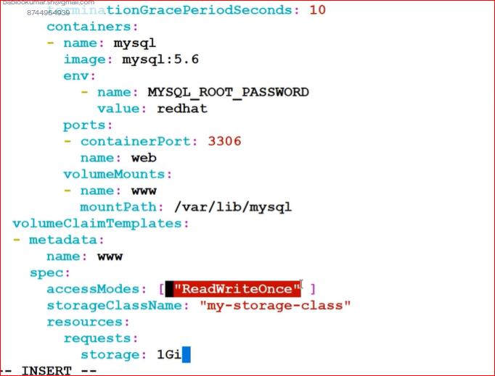

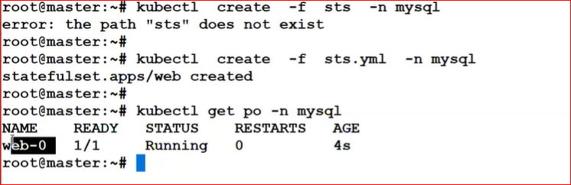

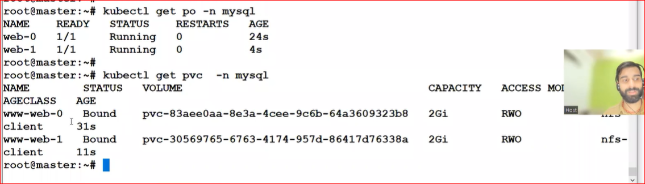

1. Multi Container Pod
2. Init Container
3. Static Pod
4. Secrets
5. Config Map
6. State full Sets.
7. Daemon Sets
8. Multi Container Pod: -

Pod: Its Contain Container

1. High availability: NO
2. Scalability: NO
3. No Load spin across the container inside the pod.
4. Ip address not assign on every container.

Use case of More Than Container inside the single pod

1. Side car

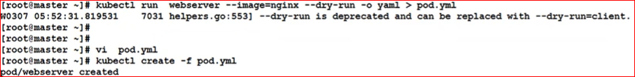

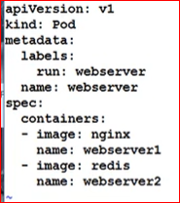

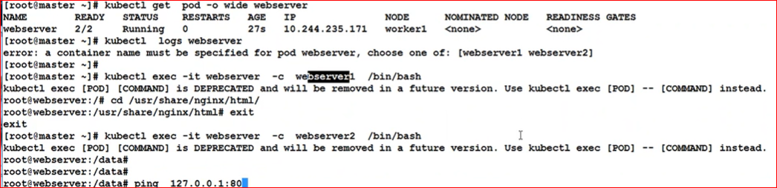

Through Loop Back Ip Communication stablish with in container if you use side car

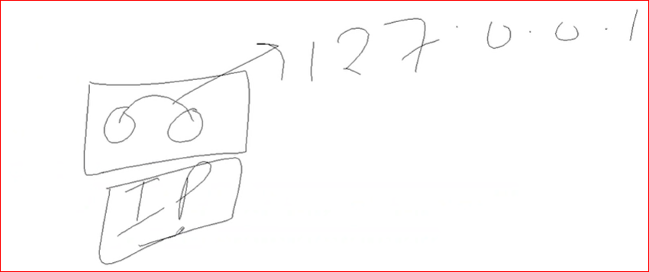

if 2 containers running in same pod than NW/Volume PVC will be same.

1. **Init Container**: -

An init container in Kubernetes is a specialized container that runs before the main application containers in a pod to prepare the environment for the main container.

**apiVersion**:v1

**kind**:Pod

**metadata**:

**name**:myapp-pod

**labels**:

**app.kubernetes.io/name**:MyApp

**spec**:

**containers**:

- **name**:myapp-container

**image**:busybox:1.28

**command**:['sh','-c','echo The app is running! && sleep 3600']

**initContainers**:

- **name**:init-myservice

**image**:busybox:1.28

**command**:['sh','-c',"until nslookupmyservice.$(cat /var/run/secrets/kubernetes.io/serviceaccount/namespace).svc.cluster.local; do echo waiting for myservice; sleep 2; done"]

- **name**:init-mydb

**image**:busybox:1.28

**command**:['sh','-c',"until nslookupmydb.$(cat /var/run/secrets/kubernetes.io/serviceaccount/namespace).svc.cluster.local; do echo waiting for mydb; sleep 2; done"]

1. **Static Pod: -**

Static Pods are managed directly by the kubelet daemon on a specific node, without the API server observing them. Unlike Pods that are managed by the control plane (for example, a Deployment); instead, the kubelet watches each static Pod (and restarts it if it fails).

Path of worker1

cd /etc/kubernetes/manifests/

Probes: -

In Kubernetes, probes are diagnostic checks that determine the health of a container or application running in a pod.

Type: -

1. Liveness Probe: -
2. TCP Based Check: Check Port listen.
3. Command Based check: any OS command can trigger
4. Url Check: http//127.0.0.1/ericsson.com
5. Readiness Probe: -
6. Startup Probe: -

Class-13

Helm & Lab

Helm: - it is Kubernetes manifests package manger.

Type: -

1. Helm Repo: there is folder which contains helm chart.

* Internet based.
* Intra based.

1. Helm chart: it’s packaged of Kubernetes resources manifests.

* Community based.
* Custom based.

Lab: -

Helm Directory Structor

1. Chart.yaml = it contains chart details

Version:

Depended:

1. Charts = It Contains depends Chart
2. Template: It Contains all api resources manifests which run this product.

Download helm from google with ubuntu based. Copy link and download with curl -o command.

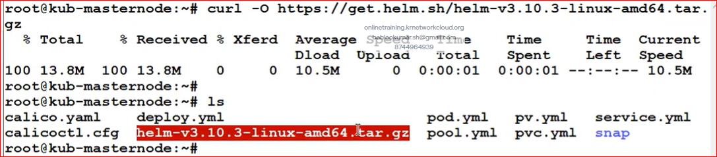

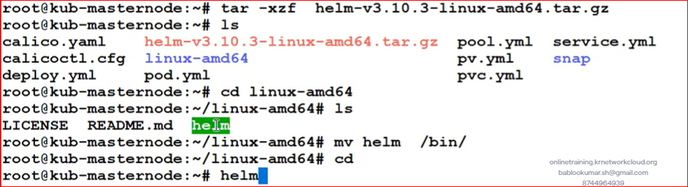

**===================== Openstack =========================**

[Part\_1: Differences between a Virtual Machine and Containers - YouTube](https://www.youtube.com/watch?v=9tiFl-pnO5M&list=PLO46x44I7udVmFtPGm5GXmH9DRzToldy2&index=13)

**